Movies Review Analysis

Group 3

## **Table of Contents**

**Table of Contents** **1**

**Abstract** **2**

**Introduction** **2**

Initial Dataset Exploration 3

Initial Data Manipulation 3

**1. Summarization and comparison of raw and Movies.csv** **4**

Raw Data Normalization 4

Summarization and Comparison 6

Critic Score Comparison 7

Audience Score Comparison 7

Result 9

2. Are there any systematic differences between critics and audience’s reviews? 9

3. Can Reviews (Critic and Audience) Predict Movie Revenues? 14

Exploratory Data Analysis (EDA): 14

Critic Scores Distribution 14

Audience Scores Distribution 15

Correlation Analysis between scores and sentiments: 16

Critic vs Audience Sentiment Analysis: 16

1. Decision Tree Visualization 23

Other Deployed Models and Model Performance Summary: 24

Key Findings: The Neural Network is the best predictor of revenues but lacks interpretability. The Decision Tree, while slightly less accurate, provides actionable insights for decision-makers. 25

4. Audience Review Analysis for 3 Movies 26

Avatar: 27

Home Alone: 31

The A-Team: 34

Analysis by different phases: 36

How Release Strategies Shape Long-Term Movie Success 37

**Conclusion and Suggestions for Data Collection** **38**

Conclusion and Takeaway 38

Suggestions for Additional Data Collection 38

## **Abstract**

This project explores the predictive power of movie reviews on box office revenues through a comprehensive analysis of Rotten Tomatoes critic and audience reviews. Utilizing two Kaggle datasets - "The Mother of All Movie Review Datasets" and "Top Box Office Revenue Data - English Movies" - we examined 56 million user reviews across 10,500 movies alongside revenue data for top-performing films. The study focused on understanding systematic differences between critics and audiences, identifying sentiment and scoring patterns, and leveraging these insights to predict movie revenues using machine learning models.

Key findings reveal significant discrepancies in critic and audience evaluations, with critics showing a higher prevalence of negative sentiment and greater score variability, while audiences display overwhelmingly positive sentiment and tightly clustered ratings. Correlation analysis highlighted moderate relationships between scores and revenues, with audience sentiment showing stronger ties to box office success.

Through machine learning techniques - including Decision Trees, Neural Networks, and Random Forests - we developed predictive models, achieving up to 83.5% accuracy. Neural Networks emerged as the best performer, while Decision Trees provided actionable insights, demonstrating that higher critic and audience scores consistently associated with greater revenues.

A case study analyzing three films - *Avatar*, *Home Alone*, and *The A-Team* - unveiled how release strategies, seasonal trends, and streaming availability shape audience sentiment and ratings over time. The study emphasizes the role of sentiment-driven audience engagement in sustaining a movie’s success across its lifecycle.

This analysis concludes that critic and audience reviews are reliable predictors of box office performance, with positive sentiment playing a pivotal role. It recommends integrating data from multiple review platforms and considering audience sentiment toward actors for deeper insights. The findings offer actionable strategies for filmmakers and distributors to optimize release strategies, enhance audience engagement, and achieve long-term success.

## **Introduction**

The goal of this project is to analyze Rotten Tomatoes reviews, we focused on several key objectives. These include identifying systematic differences in review types, predicting movie revenues, and examining movies in detail throughout their lifespan - spanning from theatrical release, DVD availability, and streaming platforms.

### **Initial Dataset Exploration**

For this project, we utilized two Kaggle datasets. The first dataset, titled *The Mother of All Movie Review Datasets*, includes 56 million Rotten Tomatoes user reviews for 10,500 movies. The second dataset, *Top Box Office Revenue Data - English Movies*, provides top box office revenue data for U.S. and international markets, categorized by franchise and genre. The links to the datasets are:

1. <https://www.kaggle.com/datasets/bwandowando/rotten-tomatoes-9800-movie-critic-and-user-reviews>
2. <https://www.kaggle.com/datasets/kalilurrahman/top-box-office-revenue-data-english-movies?select=boxofficemojoustop1000.tsv>

Upon closer examination, we found that these datasets are updated fairly regularly. According to the last update timestamps, *The Mother of All Movie Review Datasets* was last updated five months ago, while *Top Box Office Revenue Data - English Movies* was updated just 17 hours ago. Further analysis reveals that the *Top Box Office Revenue Data - English Movies* dataset is updated daily.

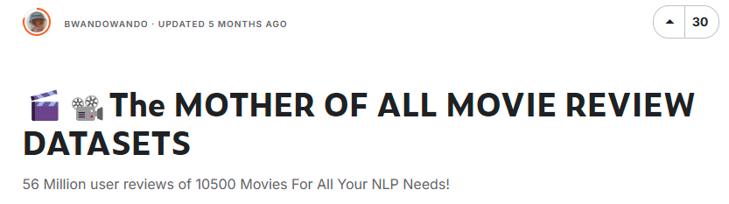

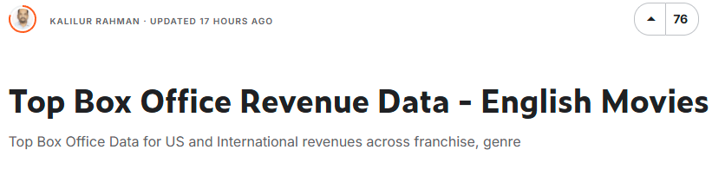

### **Initial Data Manipulation**

Before extracting information from the dataset, we needed to find an efficient way to parse the data from the large user_reviews.csv file. Due to its large size, direct processing in python would not be feasible. Therefore, several approaches were considered, such as importing the file into a MySQL database. However, we opted to parse the data into individual CSV files for each movie. This method would allow team members to work simultaneously on the dataset and the data they need without setting up a database environment.

To implement this in Python, we used multithreading to process the user_reviews.csv file in batches. This significantly reduced the processing time since the order of reviews in the user_reviews.csv file is not important, the file was divided into batches of 10,000 rows, with each thread handling one batch at a time. The threads then wrote each row to its corresponding movie-specific CSV file. This approach enables faster retrieval of information and allows direct access to specific CSV files as needed. The image below illustrates the workflow of this process.

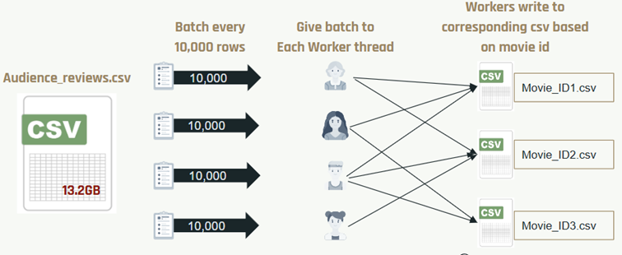

## **1. Summarization and comparison of raw and Movies.csv**

In this section, we will retrieve and calculate the average scores and sentiments for both critics and audiences using the raw data. We will then compare these results with the figures compiled by the dataset's author. This comparison will help us identify any discrepancies and investigate their potential causes.

### **Raw Data Normalization**

To begin, we need to examine the movies.csv file to understand how the dataset's author calculated sentiment. We assume the author used a score-to-sentiment approach, assigning a "positive" or "negative" sentiment based on a predetermined threshold. Using this assumption, we analyzed the audience_sentiment and critic_sentiment columns in the movies.csv dataset. This analysis involved grouping the scores into two clusters: one for scores labeled as "positive" sentiment and the other for those labeled as "negative" sentiment. The results of this analysis are outlined below:

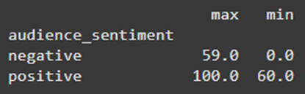

From this analysis, we could determine that the author defined a threshold of 60 and above to have a positive sentiment, while 59 and below results in a negative sentiment for a movie’s review.

The next step is to establish a method for normalizing and averaging the raw audience and critic scores. Upon analyzing the critic reviews, we inferred that the score was calculated by summing all instances where the isFresh Boolean value was true. As a result, the following formula was applied to calculate the normalized average score for critic reviews per movie:

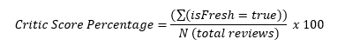

The audience score is rated on a scale of 1 to 5. Therefore, the following formula is used to calculate the normalized audience score:

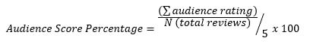

For example, here is an overview of a movie on Rotten Tomatoes with 66 critic reviews and over 25,000 audience reviews. Using the formula outlined above, we will calculate the normalized score for each set of reviews accordingly.

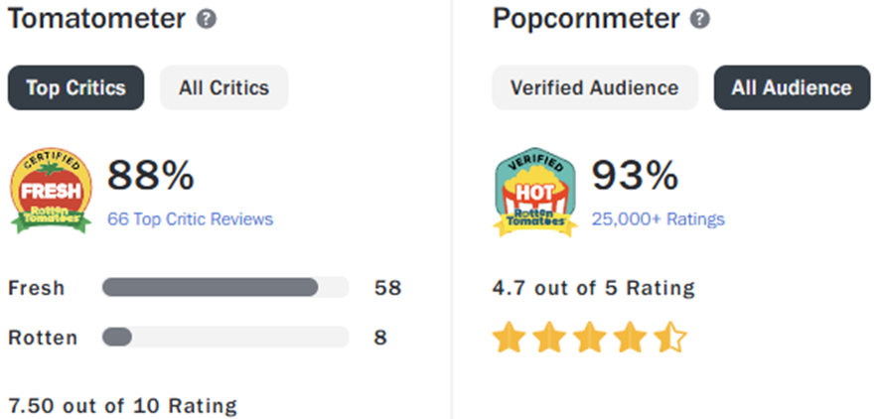

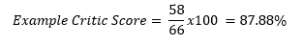

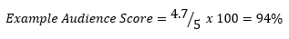

Based on the results of this example, we concluded that the formula is accurate. However, a minor discrepancy was observed in the audience score due to a rounding error when dividing the sum of all reviews by the total number of reviews. Our calculation resulted in a score of 94%, whereas Rotten Tomatoes reported a score of 93%.

Using the processes stated above, we calculated the critic and audience scores for each movie included in the raw critic and audience review CSV files. Sentiment was then determined for each critic and audience score. The resulting merged dataset, containing raw scores along with their corresponding sentiments, is shown below:

| **movieId** | **avg_audience_score** | **avg_audience_sentiment** | **avg_critic_score** | **avg_critic_sentiment** |
| --- | --- | --- | --- | --- |
| **00112b83-23bd-44ce-8ae3-f27194f651d6** | 89 | positive | 98 | positive |
| **0052d083-dc96-3f49-9413-7235c9d68c07** | 63 | positive | 48 | negative |
| **0053219a-1c37-4078-b671-3503dcd20b6a** | 36 | negative | 25 | negative |
| **…** | … | … | … | … |

### **Summarization and Comparison**

To begin this analysis, we will examine the datasets provided by the author, starting with a comparison of the number of entries, or movies, in each dataset. As shown below, the movie and raw critic CSV files contain the same number of rows. However, a preliminary analysis reveals that more movies were reviewed by audiences than by critics. After merging the raw audience and critic score datasets, we identified 10,197 movies reviewed by both groups. This suggests that some movies were exclusively reviewed by critics, while others were only reviewed by audiences.

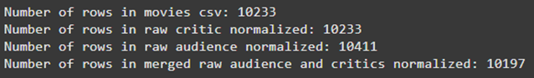

To ensure an accurate representation of the most up-to-date data uploaded by the author, we performed an outer merge to include the maximum number of movies. This approach ensures that all movies are included, whether they have been reviewed by critics, audiences, or both.



From the database of 10,477 movies, we wanted to determine if there are any discrepancies between the critic and audience reviews in the raw data and those in the provided movies.csv file. To do this, we filtered out movies that had critic or audience scores in the movies.csv file but lacked the corresponding data in the raw datasets, and vice versa. The results are as follows:





Based on these findings above, we can conclude that critics have rated 495 more movies since the author updated the movies.csv file. This suggests that Rotten Tomatoes did not remove any critic reviews, as all of them appear in the raw critic data. However, there are 13 movies in the movies.csv file that do not appear in the audience raw data, and 280 movies in the raw data that are missing from the movies.csv file. This indicates that Rotten Tomatoes has removed audience scores for 13 movies, likely for various reasons, and that audiences have reviewed 280 additional movies since the author updated the movies.csv file.

#### **Critic Score Comparison**

The first comparison will involve comparing the critic scores from the raw data with those in the movies.csv file. This analysis will help identify any discrepancies between the two datasets regarding critic ratings since the last update to the movies.csv file by the author. As a result, we found that 166 movie ratings differed between the critic ratings in the movies.csv file and the raw data. From this interpretation, we can conclude that out of 10,233 critic reviews, only 166 movies have updated ratings or 1.6%. This means that once critics have reviewed a movie, they typically focus on the latest releases rather than revisiting and reviewing older films.

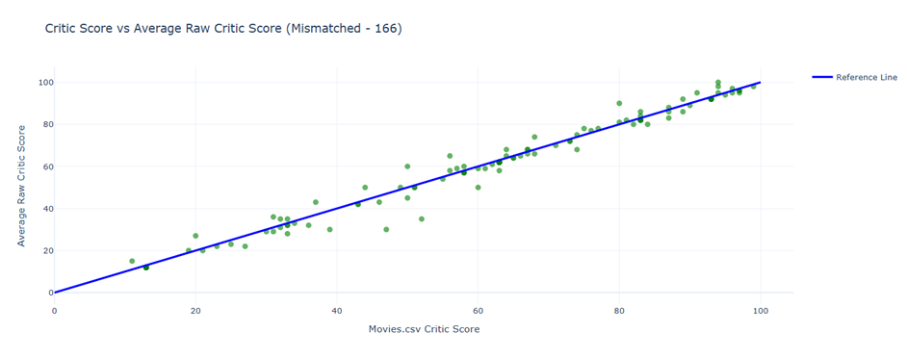

#### **Audience Score Comparison**

The second comparison involves examining audience scores from the raw data against those in the movies.csv file. Unlike the critic reviews, which show a minor update of 1.6%, audience reviews reveal a significant mismatch of approximately 94.8%. This discrepancy arises because, unlike critic scores—typically provided by reputable sources—Rotten Tomatoes audience scores are contributed by Rotten Tomatoes users worldwide. These users may or may not be verified, and the reviews could include fake submissions or bot-generated entries. Consequently, the legitimacy of these reviews is ever changing. Rotten Tomatoes has the authority to remove any reviews deemed inappropriate or unreliable based on their internal processes, ensuring that only accurate and meaningful reviews remain that accurately reflect user sentiments of the movie.

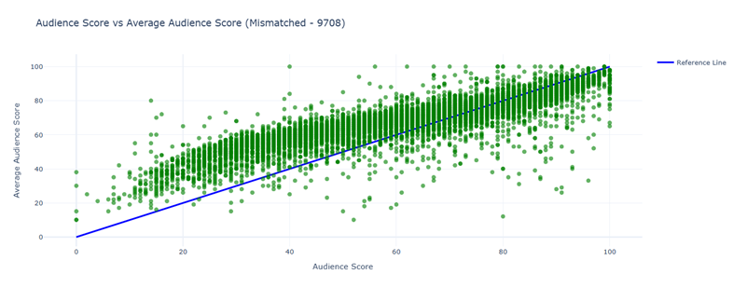

From our analysis of the reviews in movies.csv, which were compiled from an older dataset, we observe a trend where movies with initially lower audience scores tend to receive higher scores over time. However, this trend stabilizes around a score of 70, where review scores begin to converge. At this point, the differences between movie reviews become minimal, closely aligning with the reference line. This indicates that the scores in movies.csv and the raw data are generally consistent, with a margin of error of approximately ±5 points.

For example, consider a movie listed in the movies.csv file with a 100% score, while the raw data on Rotten Tomatoes shows a score of 65%. This reveals a clear discrepancy. The movie in question is *The Bad Guys: Reign of Chaos*.

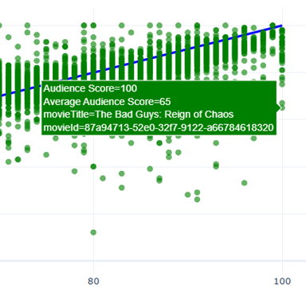

The following image is a recent screenshot from Rotten Tomatoes, captured on 12/5/2024. As shown, the audience scores include two reviews: one rated at 2.5 stars and the other at 4 stars. After averaging and normalizing these scores, the raw data score of 65% is both correct and accurate, reflecting the average audience score. In contrast, the 100% score listed in movies.csv is entirely inaccurate as there is not a single review with 5 stars.

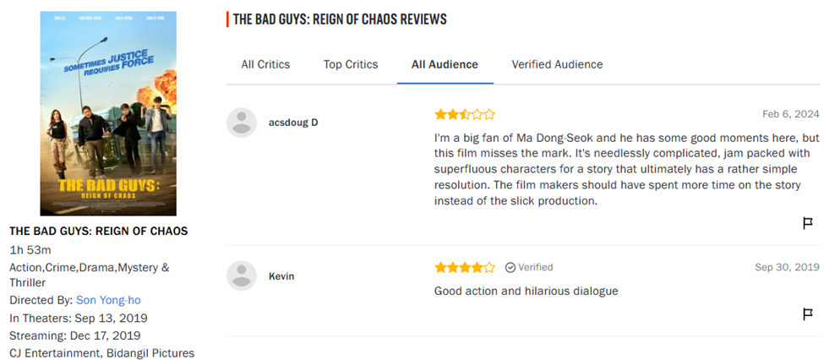

#### **Result**

In summary, we determined that the author of this dataset did not update the movies.csv file in the same way as the raw data over time. As a result, to ensure more accurate comparisons with datasets from other sources, we will prioritize using the scores from the raw data rather than those from the outdated movies.csv file. The computation of all the movie’s raw critic and audience scores along with their calculations could be found in the *CriticRawDataAverage.csv* and *AudienceRawDataAverage.csv* respectively. This could be found in the materials submitted alongside this report.

### **2. Are there any systematic differences between critics and audience’s reviews?**

**Systematic differences**

There are many ways to approach systematic differences between audience and critic reviews. However, for this analysis, three possibilities were explored: bias in data collection, measurement inconsistency, and external influences. Prior to the assessment, multiple datasets were joined and transformed.

**Data Processing** (Systematic differences) **-**

The analysis first processed 10,197 movie reviews from **RawMoviesReviews.csv**, removing 135 outliers that fell in the upper and lower quartiles. The majority of these outliers were due to missing values from either critics or audience reviews and had minimal impact on the results when removed. A **Rating Difference** column was created as the basis for comparing attributes, where a positive score difference indicated critics scored higher, and a negative score difference indicated critics scored lower than the audience.

Next, additional movie attributes, such as **Theater Type**, **Rating**, and **Original Language**, were joined from **movies.xlsx** with the original dataset, resulting in 6,456 matches. Further processing was conducted to standardize categories within the dataset. For example, the **Rating** column contained additional details about the reason for the rating and was recategorized into simplified categories: G, PG, PG-13, and R.  
*Example*:

PG-13 (Some Sensuality|Crude and Sexual Humor) was recategorized as PG-13.

Additionally, the **Original Language** attribute was standardized to remove the origin details, and a new column was created to compare English vs. non-English language films.

The final dataset was joined with **boxoffice.csv**, which did not contain a unique identifier. As a result, the joining process was performed based on movie titles. Great care was taken to ensure quality matches, using various techniques such as fuzzy matching and multi-column joins. After joining, additional processing was conducted to create a dummy variable to indicate whether a movie was **In Top 1000** or **Not in Top 1000**.

Finally, **MinMax Scaling** was attempted but was not utilized in the final analysis, as the results were not significant.

**Analysis** (Systematic differences) **-**

The initial assessment of scores revealed differences in their distribution.

Notable observations: The audience scores had a range much closer to the mean (~75), while the critics' scores exhibited a much larger range, with a significant concentration of scores at or below 60.

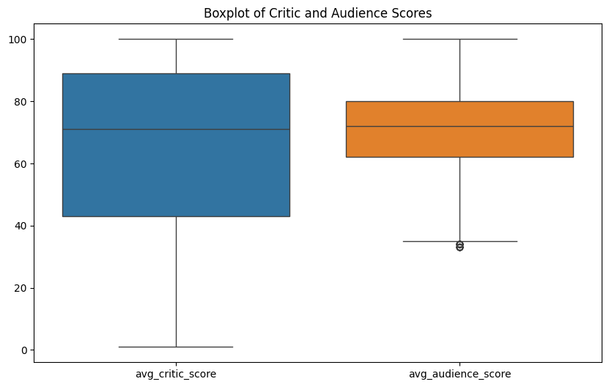

Plotting the score distribution provides a clearer picture of these differences. The audience scores are more normally distributed, while the critics' scores tend to favor extremes.

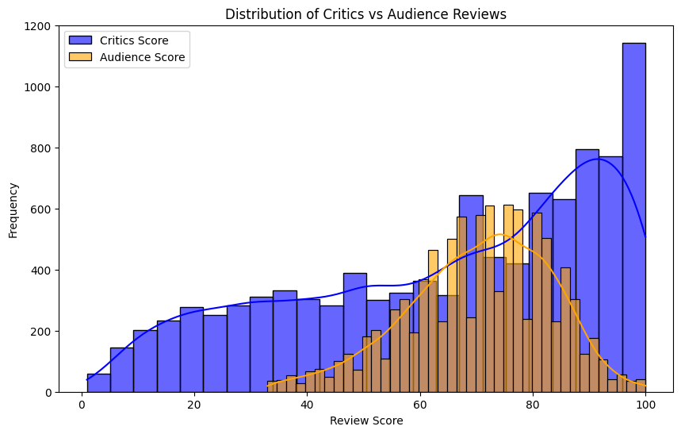

The assessment of correlation resulted in a value of 0.55, indicating a moderate relationship between the two scores.

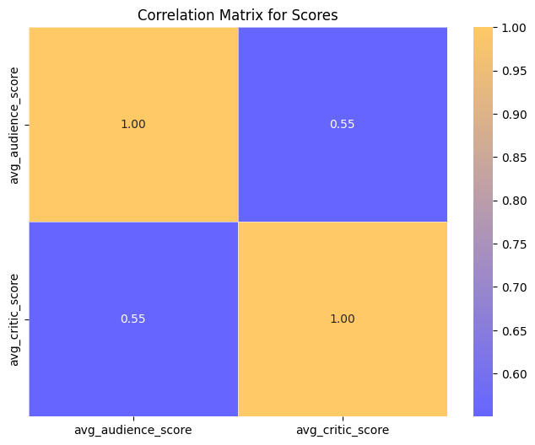

As the analysis delved deeper into potential root causes of the differences, theater types were evaluated as a possible source of bias or data collection discrepancies.

The results of this assessment revealed a statistically significant difference between critic and audience scores across different theater types. Critics showed a preference for Limited Distribution or Original releases, with the greatest disparity observed between Wide and Limited distribution. With a p-value < 0.05, we can conclude that these results are statistically significant.

Wide vs Limited - ANOVA F-statistic: 260.295 p-value: 3.459 e-57

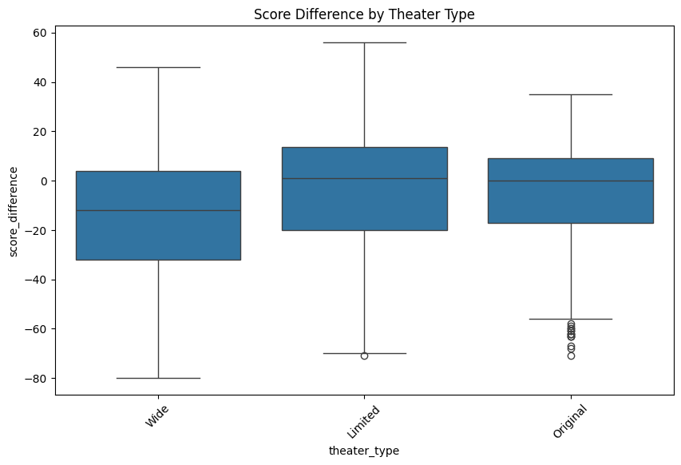

The assessment of Rating versus Score Difference yielded similar results, with a p-value < 0.05, indicating a significant difference between the rating categories. Pairwise analysis revealed that critics tend to favor the extremes, particularly R and G ratings.

Ratings Vs Score - ANOVA F-statistic: 107.747 p-value: 4.635 e-68

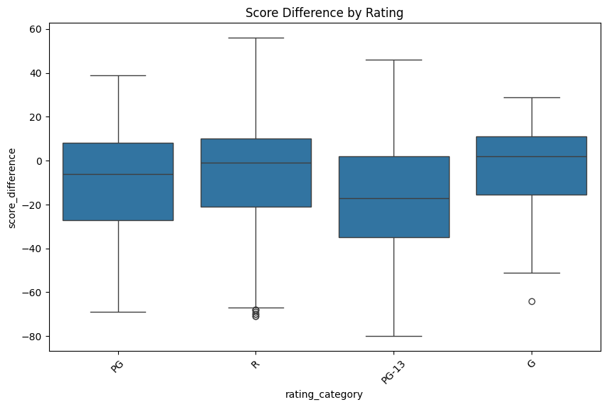

The assessment of Language (left) showed statistically significant differences among languages. To further explore potential bias toward English, an additional analysis (right) was conducted. Surprisingly, critics appeared to score non-English movies higher than English-language films.

English vs Non-English - ANOVA F-statistic: 140.202 p-value: 5.147e-32

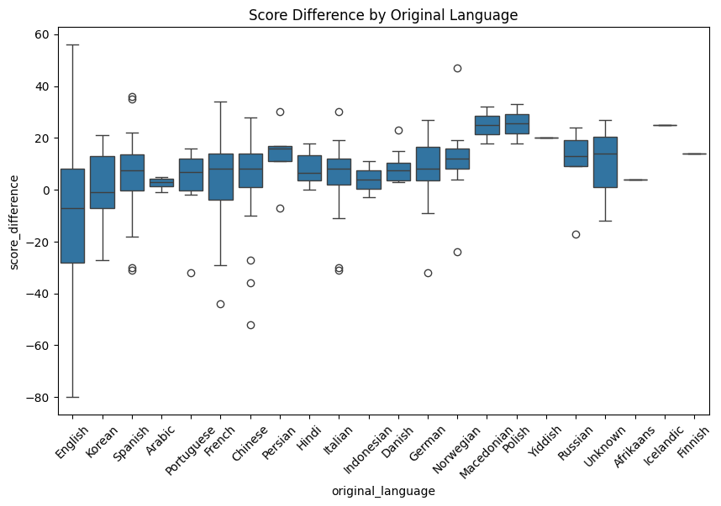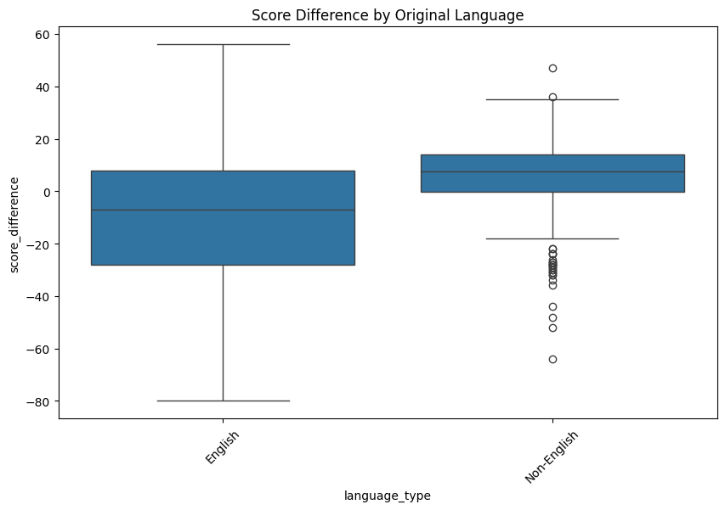

The final assessment of Score Differences vs. Revenue revealed some variation between top-grossing movies and non-top-grossing movies. The overall revenue distribution showed that movies in the top 10% far outpaced the revenue of the bottom 90% (left). Additionally, the distribution of critics' scores appeared to favor higher ratings for top-grossing movies (right).

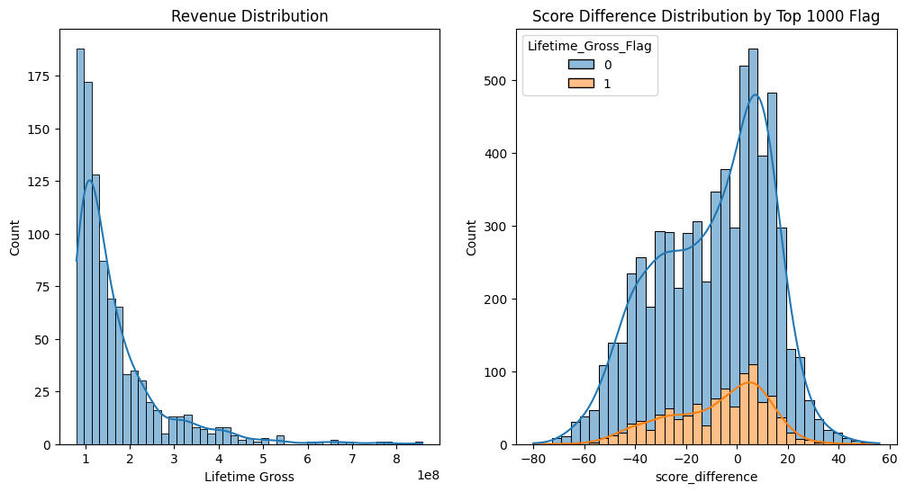

Further assessment of Top-Grossing vs. Non-Top-Grossing Movies revealed that critics tend to favor top-grossing movies, showing a marginally positive score difference and fewer negative differences (as seen in the violin plot). While this difference was statistically significant, it was less pronounced compared to other findings.

Top Gross vs Non-Top Gross ANOVA F-statistic: 8.245 P-value: 0.0040

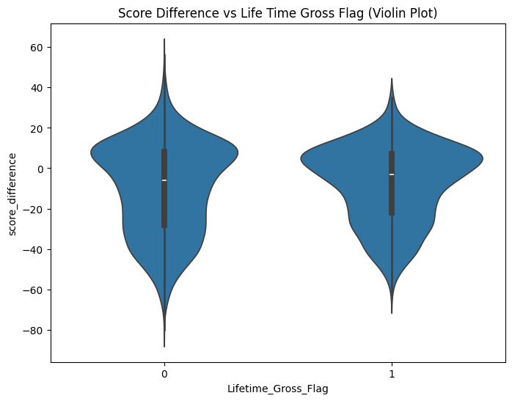

**Conclusion** (Systematic differences) **:**

This analysis suggests that there are systematic differences in how critics and audiences rate movies. Critics appear to evaluate movies differently across categories such as rating, language, theater type, and revenue. This may indicate potential biases in data collection (e.g., preference bias) or influence from external factors like market demand.

Additionally, there were signs of measurement inconsistencies, as critics generally gave more extreme ratings. While further assessment is needed, particularly regarding the number of critic and audience ratings in the outlier groups, it is safe to conclude that systematic differences likely exist in how critics and audiences rate movies.

### 

### 

### 

### 

### 

### 

### 

### 

### 

### **3. Can Reviews (Critic and Audience) Predict Movie Revenues?**

This study explores the relationship between movie reviews—comprising critic and audience scores and sentiments—and box-office performance for the top 1000 movies, measured by lifetime gross revenue. Through statistical analysis, visualizations, and machine learning models, the analysis determines how effectively reviews predict financial success.

In the highly competitive movie industry, understanding the factors driving box-office success is critical. Reviews from critics and audiences are thought to play a significant role in shaping movie revenues. This report investigates:

1. How critic and audience evaluations (scores and sentiments) relate to lifetime gross.
2. The predictive potential of these evaluations on movie revenues using machine learning techniques.

### **Exploratory Data Analysis (EDA):**

#### **Critic Scores Distribution**

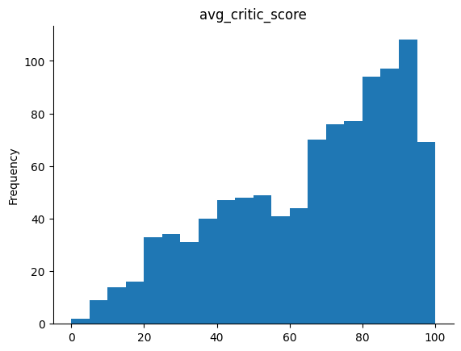

* **Score Range:** 0–100. Most movies fall within 40–100.
* **Insights:** A right-skewed distribution reflects that movies generally receive favorable critic reviews. Movies with low critic scores (< 40) are rare, while higher-performing movies cluster around scores of 80–100.

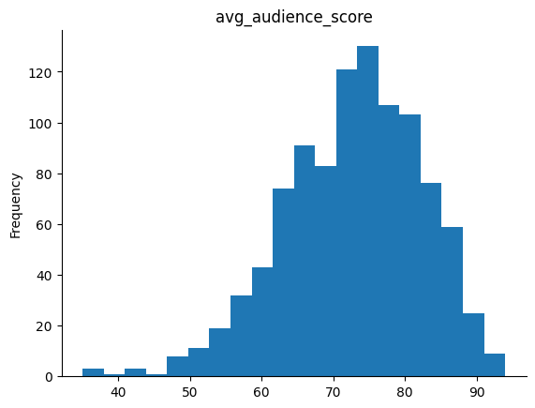

#### **Audience Scores Distribution**

* **Score Range:** 40–95.
* **Insights:** A bell-shaped distribution indicates that audiences are more moderate in their evaluations. Scores between 70 and 80 are the most common, while scores below 50 are infrequent.

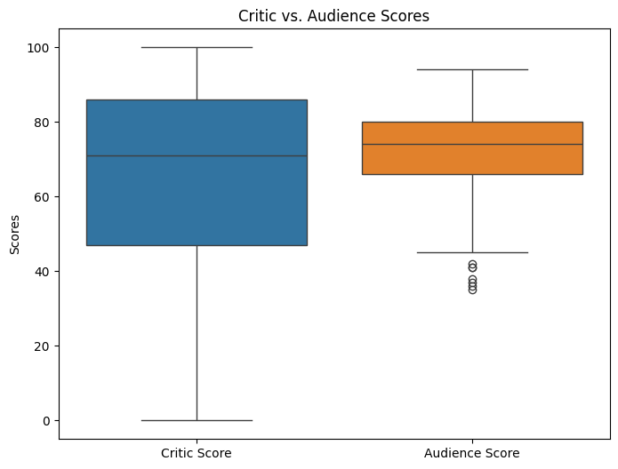

#### 

#### **Correlation Analysis between scores and sentiments:**

**Critic Sentiment & Scores:** Strong positive correlation (0.868). **Audience Sentiment & Scores:** Moderate correlation (0.618). **Rank & Lifetime Gross:** Correlation of -0.801 indicates that lower-ranked movies (closer to 1) earn higher revenues. **Revenue Correlation:** While scores positively correlate with revenue, the relationship is moderate, suggesting other factors also influence gross earnings.

#### **Critic vs Audience Sentiment Analysis:**

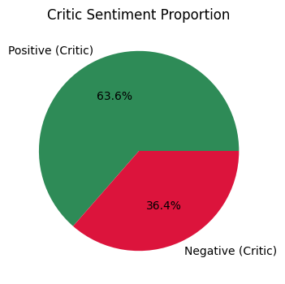

**Critic Sentiment:** Positive Sentiment (1): 63.56% of movies received positive sentiment. Negative Sentiment (0): 36.44% of movies received negative sentiment. Critics have a more balanced distribution between positive and negative sentiments, with a notable portion of movies getting negative reviews.

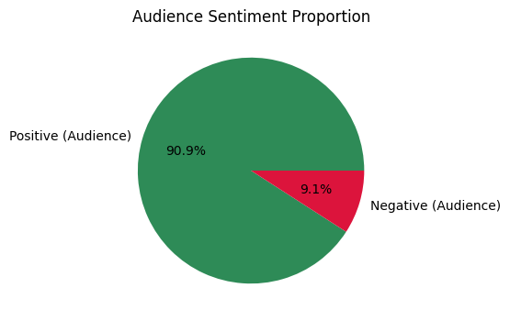

**Audience Sentiment:** Positive Sentiment (1): 90.89% of movies received positive sentiment. Negative Sentiment (0): 9.11% of movies received negative sentiment. Audience sentiment is overwhelmingly positive, indicating that audiences are generally more lenient and favorable in their reviews compared to critics.

**Key Comparisons:**

**Between Critics and Audiences** **Scores:** Average audience scores (72.90) are higher than average critic scores (65.40), showing that audiences tend to rate movies more positively. Audience scores are more tightly distributed (lower standard deviation) compared to critic scores, suggesting less variability in audience ratings. **Between Critics and Audiences Sentiment:** Critics have a higher proportion of negative sentiment (36.44%) compared to audiences (9.11%). Audiences overwhelmingly favor movies, with over 90% of reviews being positive.

Audience scores are more consistent and less extreme, with a narrower range (35–94) compared to critic scores (0–100).

**Understanding the relationship between Rank vs Revenue (Lifetime Gross) with critic and Audience’s scores and sentiments:**

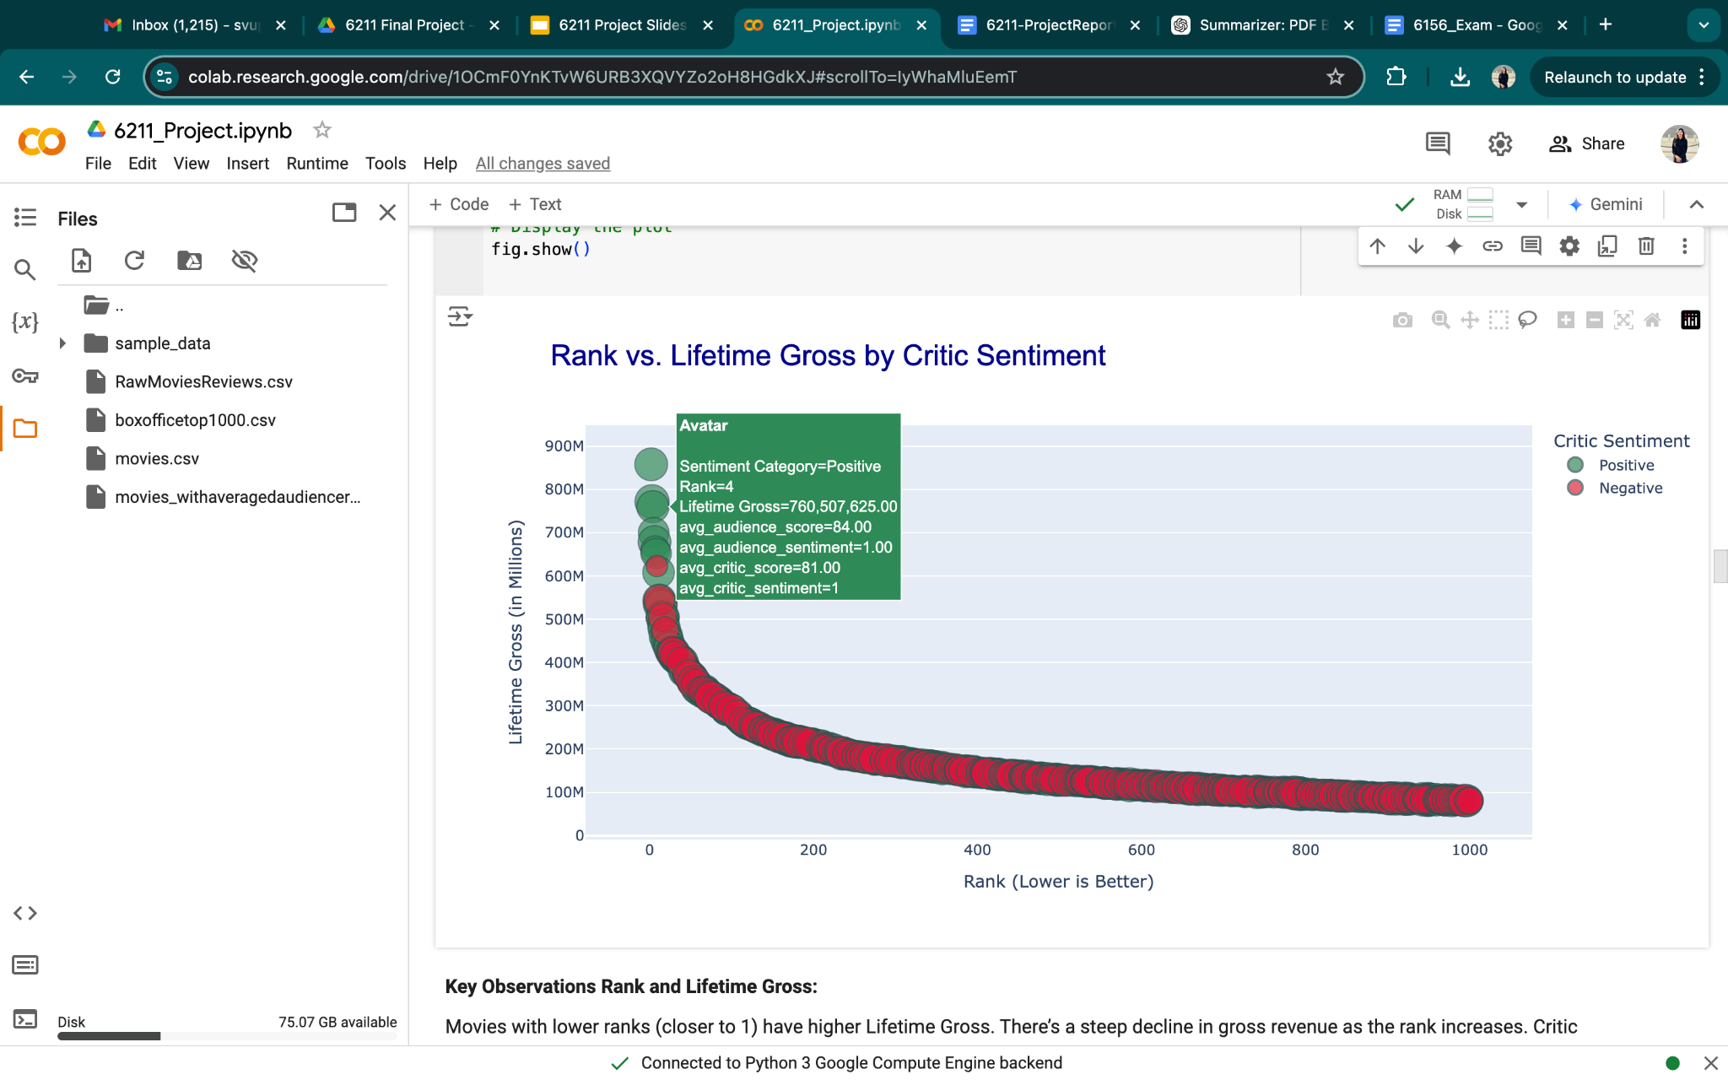

**By Critic Sentiment:** Movies with lower ranks (closer to 1) have higher Lifetime Gross. There’s a steep decline in gross revenue as the rank increases. Critic Sentiment: Positive Sentiment (Green): These movies dominate the top ranks and higher Lifetime Gross categories. Negative Sentiment (Red): These movies are more evenly spread across the ranks and tend to cluster at lower Lifetime Gross values. Movie Revenue Trends: Positive sentiment is strongly associated with blockbuster movies (high Lifetime Gross and low ranks). Negative sentiment movies do not typically break into the top-grossing ranks.

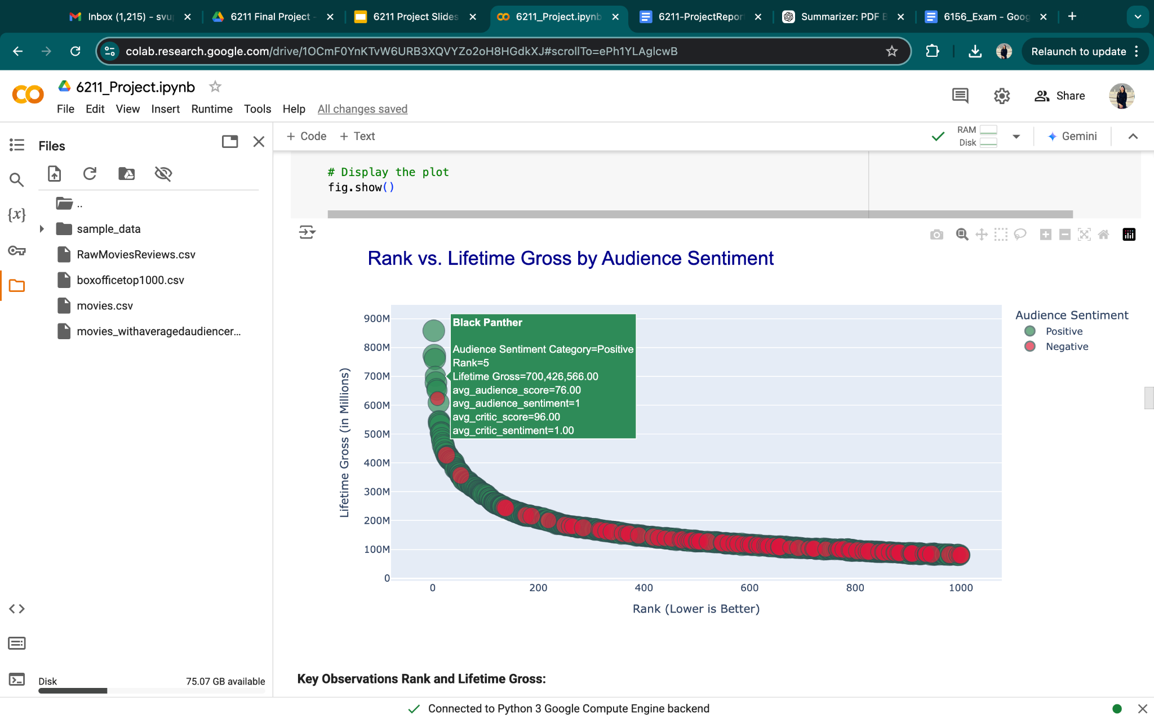

**By Audience Sentiment:** Similar to the critic sentiment plot, lower-ranked movies (closer to rank 1) have significantly higher Lifetime Gross. Gross revenue decreases sharply as the rank increases. **Audience Sentiment:** Positive Audience Sentiment (Green): These movies dominate the top ranks and higher Lifetime Gross categories. The overwhelming presence of green bubbles highlights that positive sentiment is prevalent and correlates with better box-office performance. Negative Audience Sentiment (Red): These movies are scattered more broadly across the dataset. There are fewer negative sentiment movies, especially among the highest-grossing ranks.

**Comparison with Critic Sentiment:** Audience sentiment (positive) is even more dominant in high-grossing movies compared to critic sentiment. Negative audience sentiment is relatively rare, suggesting audiences generally rate movies more favorably than critics.

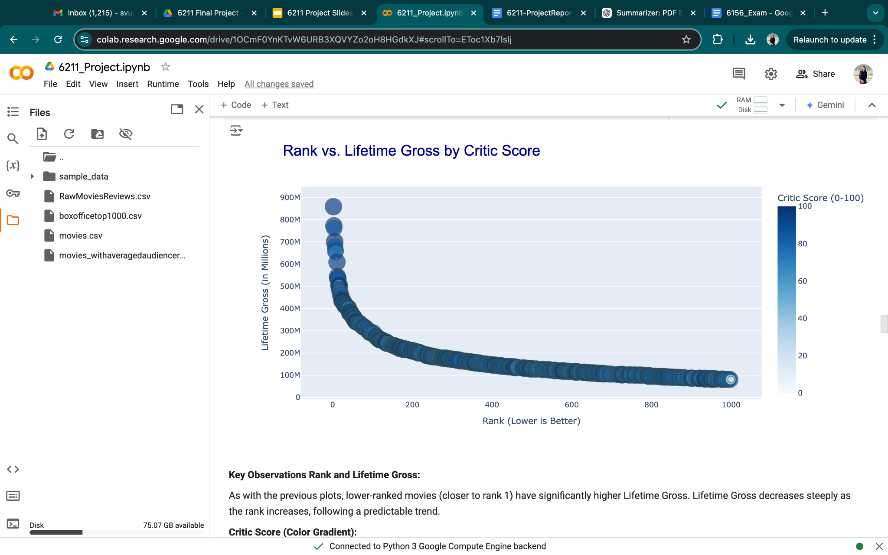

**By Critic Score:** Higher Critic Scores (darker blue) are more concentrated in the low-rank, high-gross region. Movies with lower Critic Scores (lighter blue) are distributed more evenly across ranks but dominate the lower grossing region. Top-Grossing Movies: Movies with very high Lifetime Gross (e.g., above $700M) tend to have high Critic Scores, reflecting the alignment between critical acclaim and commercial success. Broader Spread of Critic Scores: While the top ranks correlate well with higher critic scores, mid- and lower-ranked movies exhibit a wider range of scores.

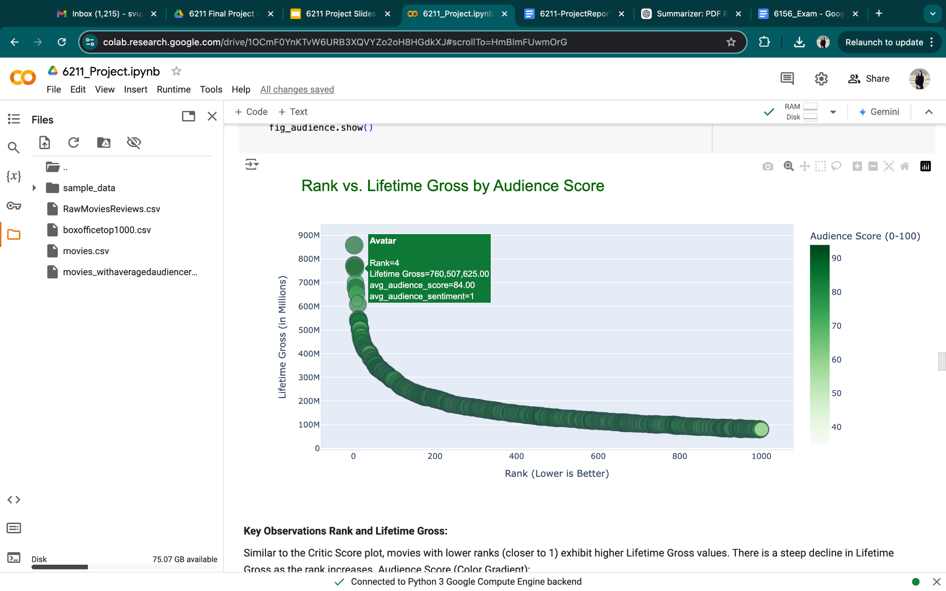

**By Audience Score:** Similar to the Critic Score plot, movies with lower ranks (closer to 1) exhibit higher Lifetime Gross values. There is a steep decline in Lifetime Gross as the rank increases. Audience Score (Color Gradient): Higher Audience Scores (darker green) are predominantly associated with the highest Lifetime Gross movies. Movies with lower Audience Scores (lighter green) are distributed more broadly, especially in mid- and lower-grossing categories. Movies in the highest Lifetime Gross category (e.g., above $700M) tend to have consistently high Audience Scores, indicating that audience approval is strongly correlated with commercial success. Wider Distribution of Scores: Audience Scores, while generally positive, exhibit more variability in the mid- and low-ranked movies, indicating that not all movies with low revenues receive low audience ratings.

**Comparison with Critic Scores** **Alignment with Lifetime Gross:** Both Critic Scores and Audience Scores show a positive relationship with higher Lifetime Gross, particularly for top-ranking movies. Audience Scores are generally more favorable (higher on average) and may not penalize movies as harshly as critics do.

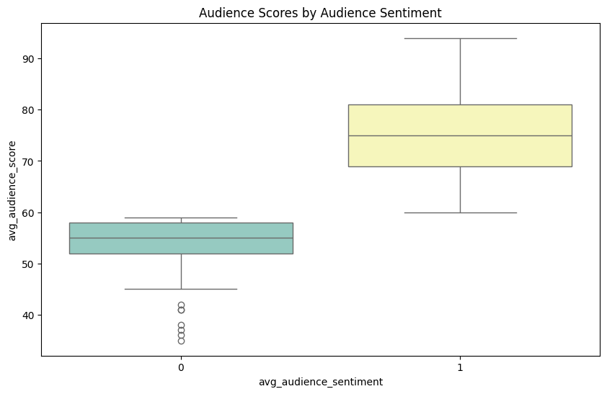

**Positive Sentiment (Yellow):** Most movies with positive audience sentiment are spread across a wide range of critic scores, from around 20 to close to 100. This suggests that even movies with lower critic scores can still receive positive feedback from audiences.

**Negative Sentiment (Green):** Movies with negative audience sentiment are concentrated in the lower ranges of both critic and audience scores. This indicates that movies with low critic scores tend to align with negative audience reactions as well.

**Key Observations** **Audience Scores with Negative Audience Sentiment (0):** The median audience score is approximately 55. The interquartile range (IQR) spans from 50 to 60, showing a narrow spread. There are outliers below 50, indicating that some negatively rated movies received very low audience scores. **Audience Scores with Positive Audience Sentiment (1):** The median audience score is approximately 75. The IQR is much wider, spanning from 70 to 85, reflecting a greater range of audience ratings for positively rated movies. The highest audience scores reach above 90, with no significant outliers below the lower bound.

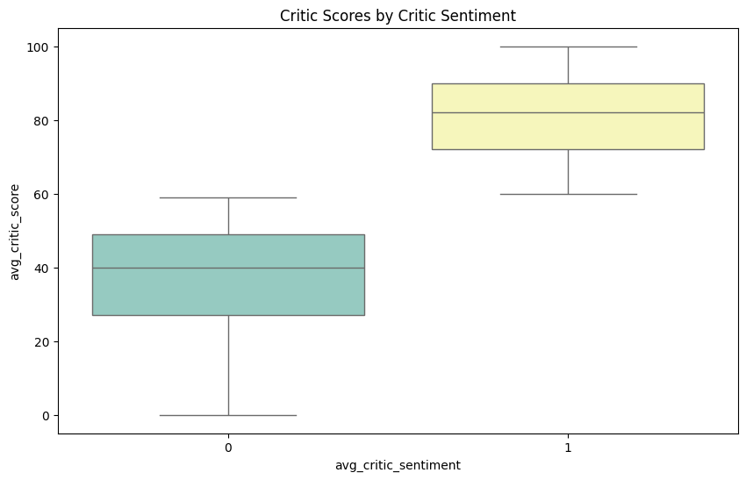

**Key Observations** **Critic Scores with Negative Critic Sentiment (0):** The median score is approximately 45. The interquartile range (IQR) spans from 25 to ~60, indicating a moderate spread of scores. A few movies scored as low as 0, reflecting very poor critic ratings for some negatively reviewed movies. **Critic Scores with Positive Critic Sentiment (1):** The median score is approximately 85, nearly double the median score for negative sentiment movies. The IQR spans from 75 to ~95, showing less variability compared to the negative sentiment group. Scores are concentrated in the higher range, with no extreme outliers.

**Comparison Between Sentiments:** Movies with Positive Critic Sentiment have significantly higher scores, with their median score being ~40 points higher than movies with Negative Sentiment. Negative sentiment movies show a wider range of scores, indicating a mix of moderately and poorly rated movies.

Positive critic sentiment is strongly associated with high critic scores, as expected. Negative critic sentiment correlates with lower scores but exhibits more variability, suggesting that not all negatively rated movies are severely criticized.

**Audience Score and Critic Score Correlation:** There's a positive correlation between critic scores and audience scores, as points generally trend upward to the right. However, there are outliers, indicating that critic scores do not always align with audience preferences. Size of Points (Total): Larger points, indicating higher "Total" values, are mostly associated with movies that have high audience scores and positive sentiment. This suggests that movies well-received by audiences tend to perform better overall. *Interesting Outliers:* Some movies with lower critic scores (around 20-50) still have reasonably high audience scores (above 60), showing a divergence between critical reception and audience enjoyment. Conversely, there are very few cases where high critic scores (above 90) receive low audience scores, showing a tendency for critically acclaimed movies to also be appreciated by audiences.

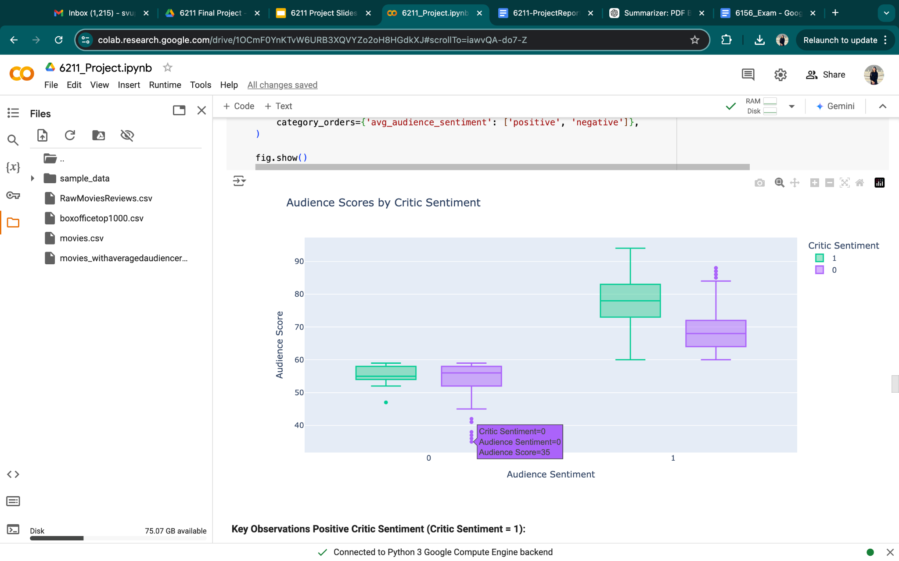

**Contrast Between Groups:** Movies with positive critic sentiment have significantly higher audience scores, with their medians separated by approximately 20 points. Negative critic sentiment correlates with lower audience scores, though the variability is less pronounced compared to positive sentiment. Interpretation

**Critic-Audience Alignment:** Positive critic sentiment is strongly associated with higher audience scores, suggesting alignment between critics and audiences for well-received movies. Critic-Audience Divergence:

For movies with negative critic sentiment, audience scores tend to be lower but slightly more spread out, highlighting occasional divergence in preferences.

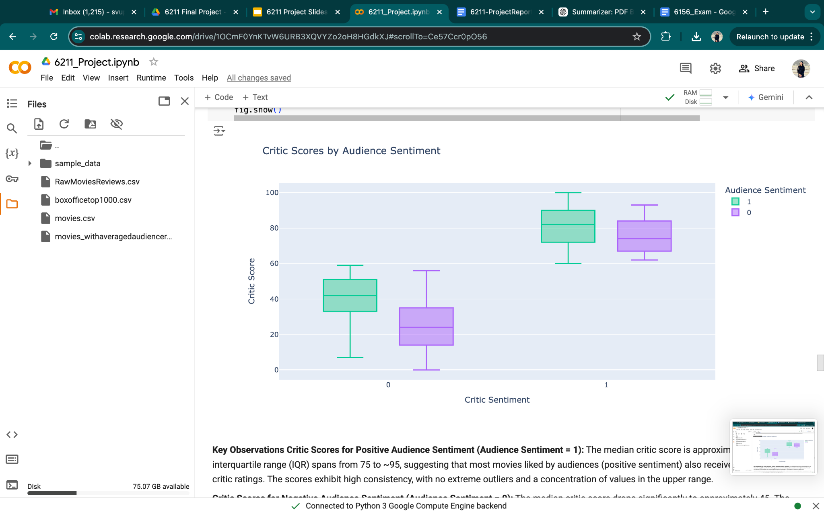

**Comparison Between Groups:** Positive audience sentiment correlates with much higher critic scores compared to negative sentiment, with a median score difference of approximately 40 points. The spread of scores is wider for positive audience sentiment, indicating greater variability for well-received movies.

**Interpretation** **Critic-Audience Agreement:** Positive audience sentiment strongly aligns with higher critic scores, indicating agreement between audiences and critics for well-received movies. Critic-Audience Divergence: Negative audience sentiment correlates with lower critic scores, but the narrower range suggests a consistent disapproval from critics as well. General Trends: Movies favored by audiences tend to perform well with critics, while negatively perceived movies are poorly rated by both groups.

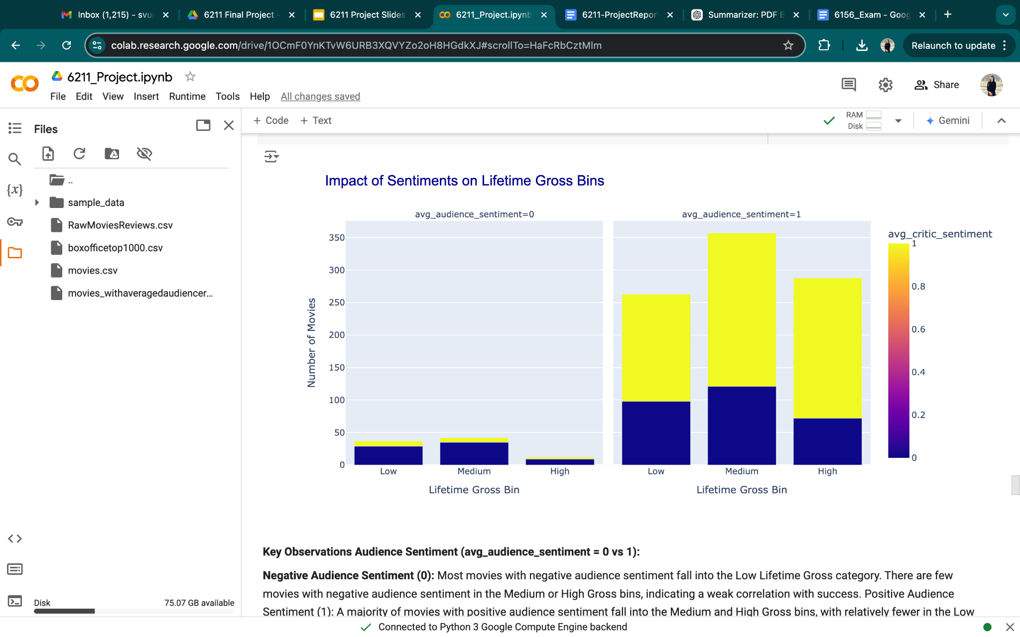

**Interpretation** **Audience Sentiment Drives Success:** Positive audience sentiment has a strong impact on pushing movies into higher grossing categories, while negative sentiment correlates with lower box-office earnings.

**Critic Sentiment Alignment:** Critic sentiment aligns closely with audience sentiment, particularly for Medium and High Gross bins, reinforcing the idea that critical and audience acclaim go hand-in-hand for successful movies. Low Gross Bin Outliers:

Movies in the Low Gross Bin are more negatively received by both critics and audiences, suggesting limited commercial and critical appeal.

**Predictive Modelling:**

To predict the revenues of the top 1000 movies using critic and audience scores and sentiments, several predictive modeling techniques were employed. These models were selected based on their assumptions, interpretability, and the behavior of the variables. Each technique offers unique strengths and is evaluated for its predictive accuracy and deployment feasibility.

#### **Decision Tree Visualization**

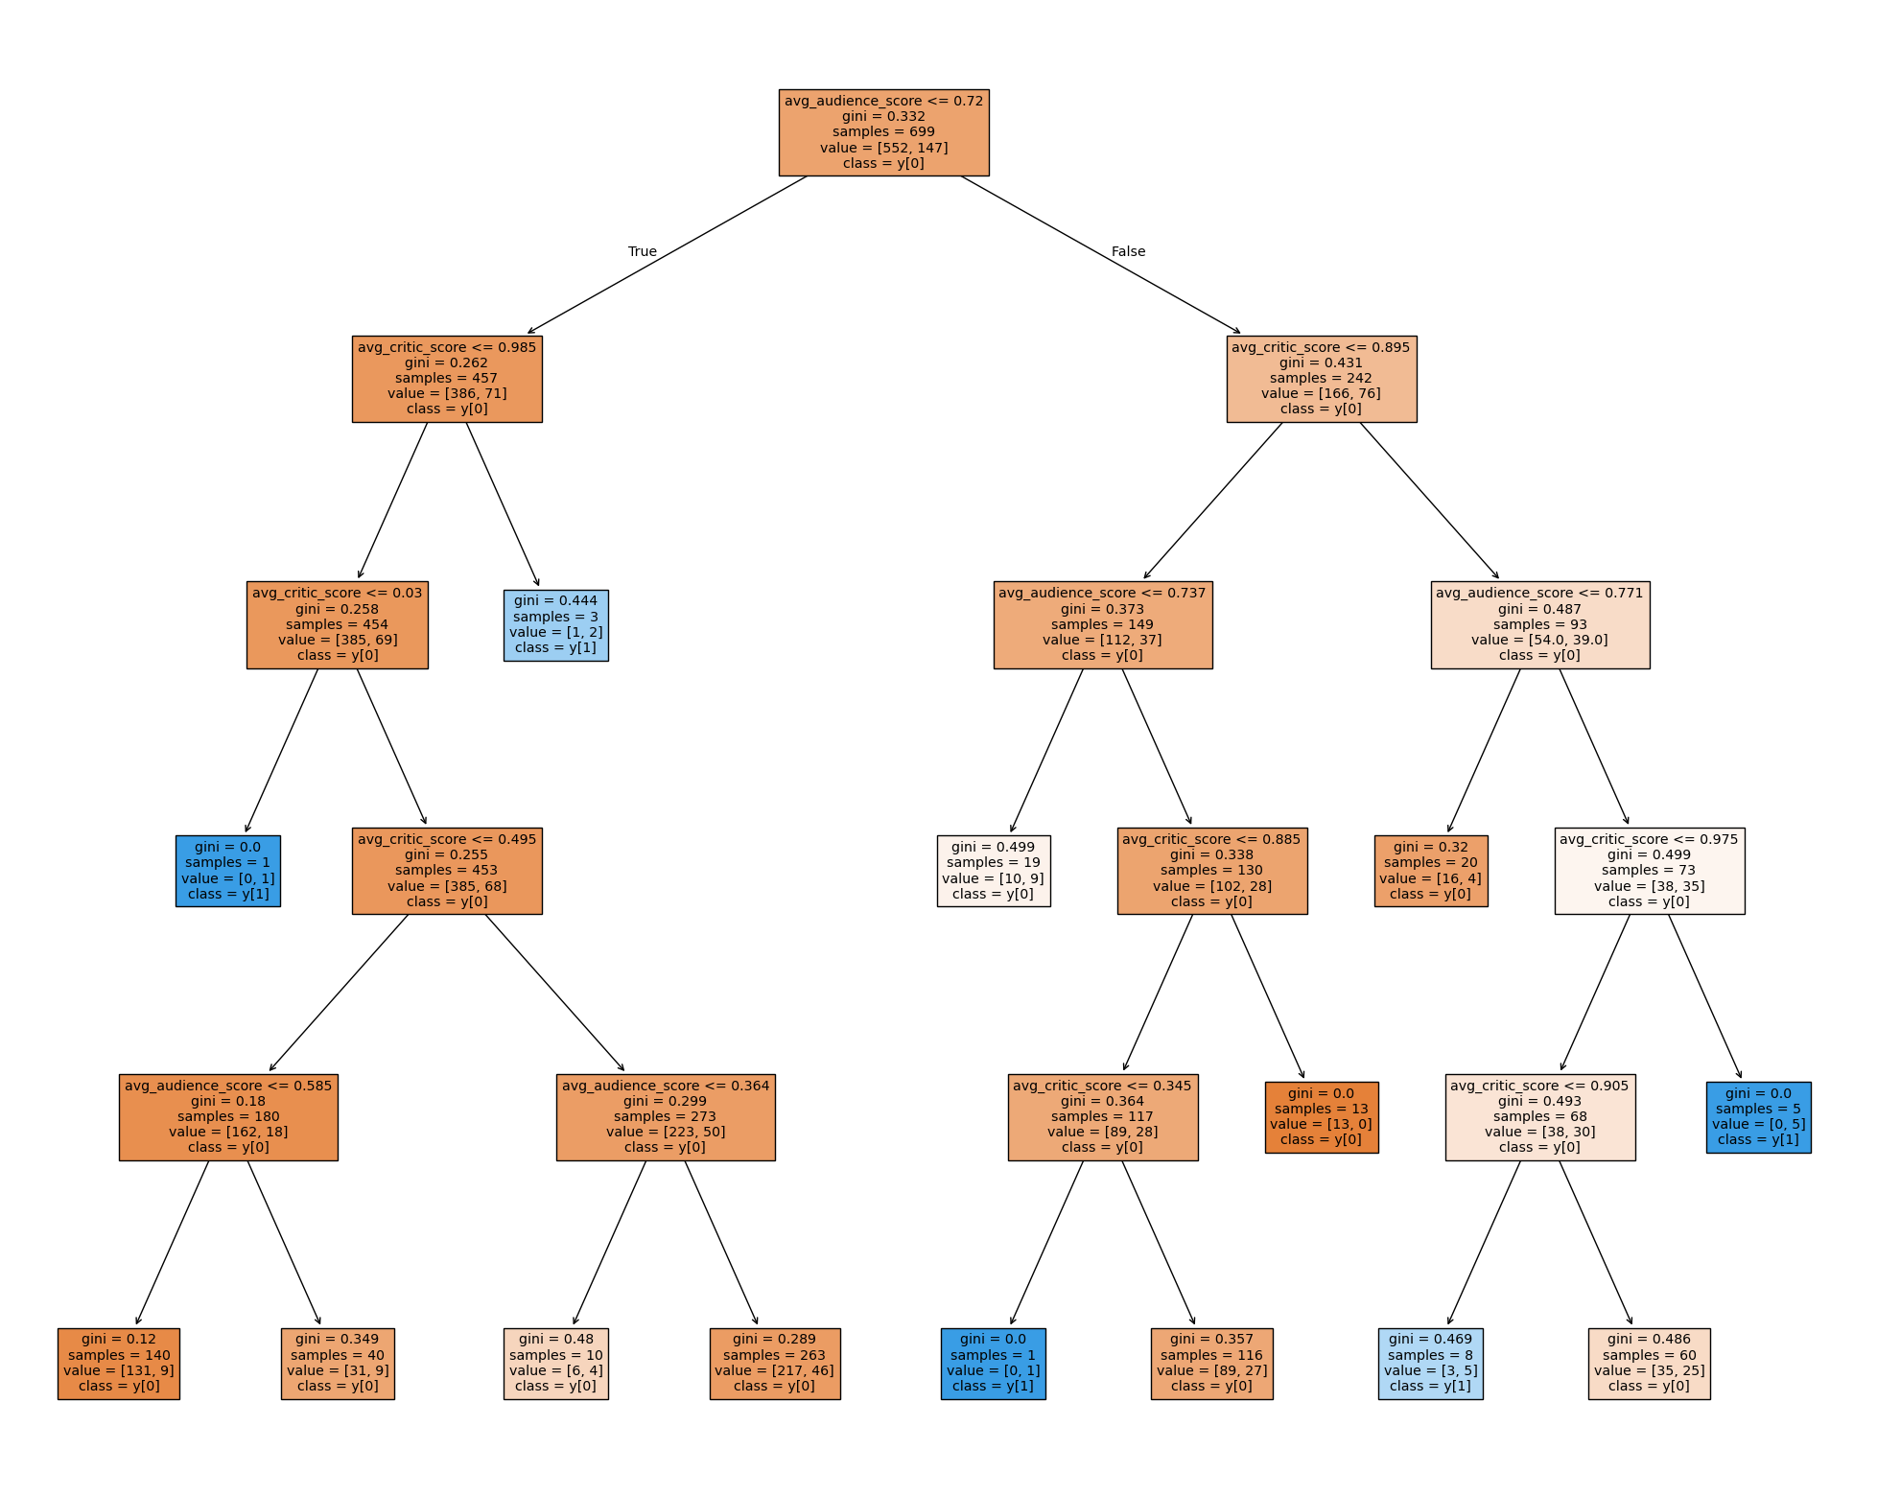

* Splitting rules from the decision tree shows that a combination of audience and critic scores can effectively separate movies into revenue categories.
* For example, movies with high critic scores (> 0.895) or audience scores (> 0.737) are consistently associated with higher revenues.

#### **Other Deployed Models and Model Performance Summary:**

| **S.no** | **MODEL** | **ACCURACY** |
| --- | --- | --- |
| 1 | Decision Tree | 81% |
| 2 | Random Forest | 77.67% |
| 3 | Naive Baseline | 80.67% |
| 4 | K-nearest Neighbour | 80.6% |
| 5 | Neural Network | 83.5% |

#### 

#### **Key Findings:** The Neural Network is the best predictor of revenues but lacks interpretability. The Decision Tree, while slightly less accurate, provides actionable insights for decision-makers.

**Can reviews predict revenues?**

Yes, to a significant extent. Reviews, particularly critic and audience scores and sentiments, are valuable predictors of box-office performance. Positive sentiments and high scores correlate with higher lifetime gross, and machine learning models validate the predictive power of these features.

### 

### **4. Audience Review Analysis for 3 Movies**

The project aims to analyze movie reviews from three popular films: *Avatar*, *Home Alone,* and *The A-Team*, focusing on their ratings and sentiments over time.

We performed a time-series analysis for these movies, using a monthly temporal unit, and visualized the trends over the entire period for which user reviews were available. To gain insights into audience perceptions, we conducted text mining on these three movies. Also, to get a perceptive of shift in user sentiments and rating, we did ratings analysis and sentiment analysis over three phases-

**Release Phase**: Covers the first three months after the movie's theatrical debut, reflecting initial audience excitement.

**Intermediate Phase**: Occurs between theatrical release and home media availability, such as DVD or digital sales.

**Streaming Phase**: Begins when the movie becomes accessible on streaming platforms, showing long-term audience interest.

To assess the emotional tone of textual reviews and determine how audiences felt about each movie over time, each review's text was processed using sentiment analysis tools, such as VADER and TextBlob. These tools assigned numerical sentiment scores.Similar to ratings, the sentiment scores were averaged on a monthly basis for each movie.Line plots were used to display sentiment trends over time, alongside the ratings for comparative analysis.Sentiment scores provided a deeper layer of understanding by capturing the emotional context behind user ratings. Periods of high ratings often corresponded with positive sentiment, while periods of lower ratings were linked to more negative sentiment.

To observe how user ratings evolved over time and identify any significant trends or patterns, for each movie, user ratings were aggregated on a monthly basis, calculating the average rating for each time period.We plotted these monthly average ratings on line graphs, enabling us to track how user ratings fluctuate over the time span for which reviews were available.

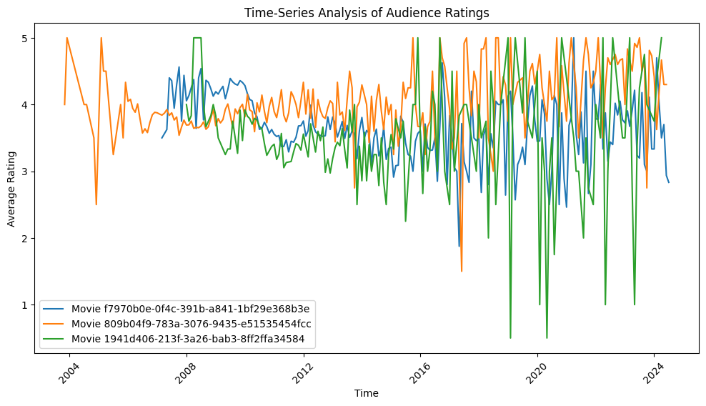

All three movies exhibit significant fluctuations in their average ratings over time. There are some discernible seasonal patterns, particularly for movie Home Alone, where we see spikes in ratings during certain periods. This suggests that external factors, such as holidays or special events, might influence audience sentiment. While all three movies show fluctuations, their overall trends differ. Avatar seems to have a slight downward trend, while Movie The A-Team shows more pronounced peaks and troughs.

##### **Avatar:**

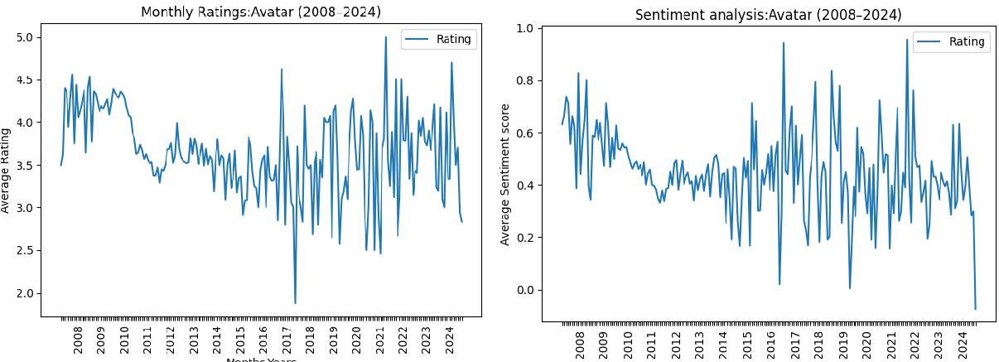

The movie Avatar started off with very strong ratings, likely due to the anticipation and excitement around its release in 2009. Over the subsequent years, the ratings have fluctuated significantly, with periods of high ratings intermixed with lower ratings periods. Despite the 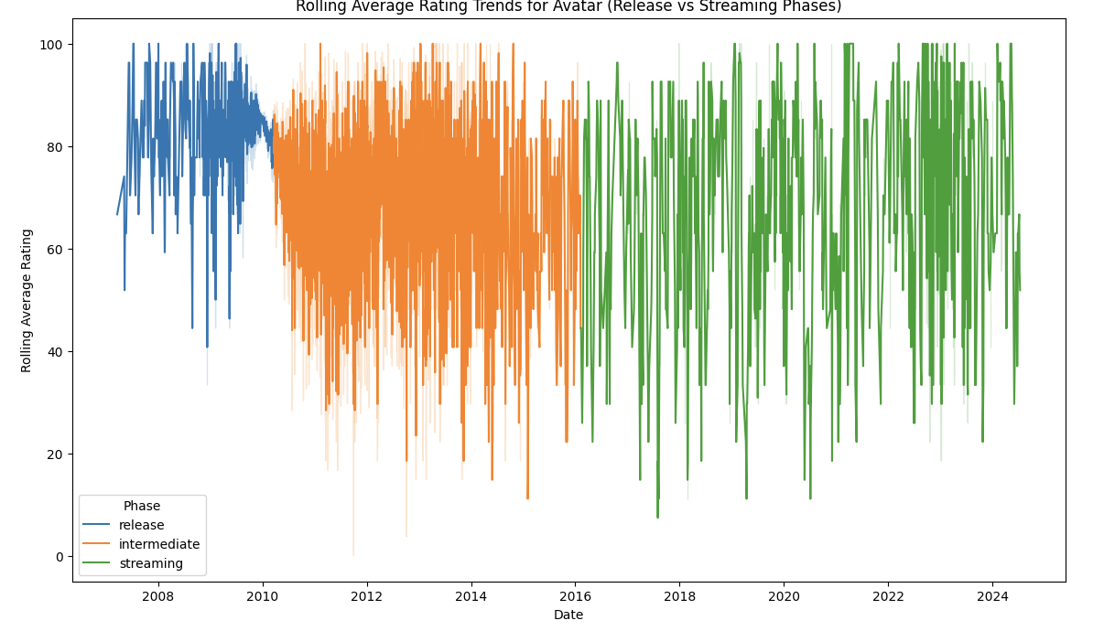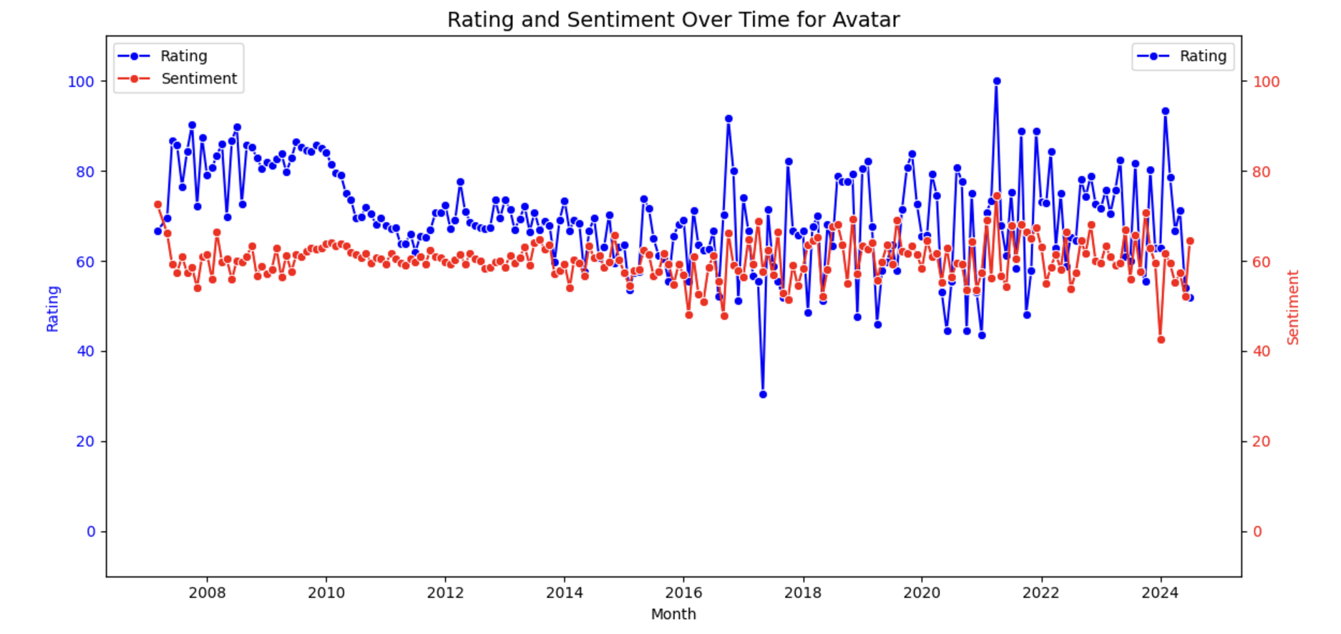

volatility, the overall average rating for Avatar has remained relatively stable, hovering around 4.0 for much of the time period. The sentiment score is very accurately inline to the ratings for this movie. Avatar became more widely available on streaming around 2017 and we see a dip in sentiment because the animation might not be justified on TV vs as in theatre causing disappointment and impacting how viewers rated the experience and further a spike can be seen in pandemic people streamed a lot that probably is reflected by the spike.The chart clearly shows a strong correlation between the average rating and the average sentiment score. Periods of high ratings generally coincide with high positive sentiment, while lower ratings align with more negative or neutral sentiment. This suggests that user reviews and ratings are closely tied to the overall emotional response and perception of the film.

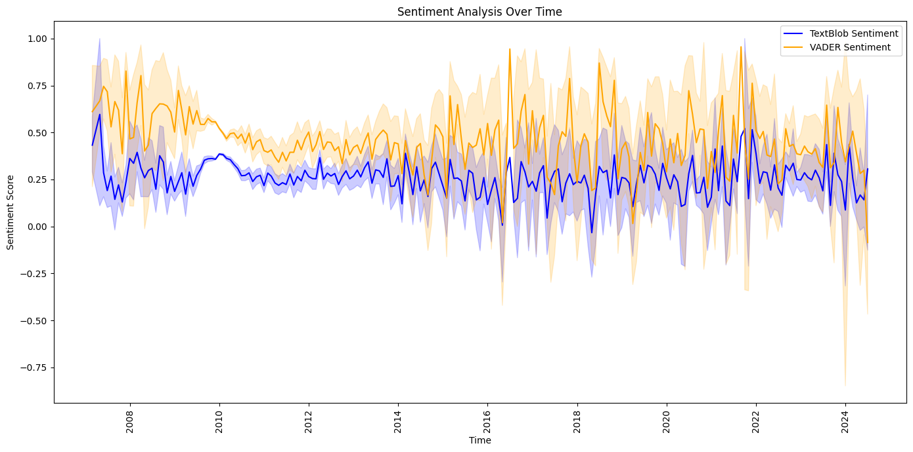

We tried sentiment analysis using TextBlob and VADER to get slightly different sentiment scores for the same textual data. To understand more about the sentiment we did a word2vec and found most similar words. The average sentiment for this movie was 73.55 and the top 20 words are shown in the figure below along with the frequency of top words.

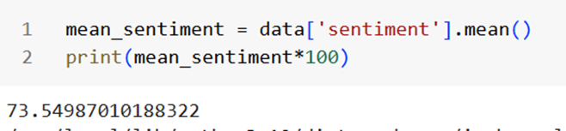

For the word effect, we find “visual”, “great”, “amaze” as similar keywords which show the movie was widely accepted by the public. The top frequency words have “3d” and “visual”, “effect”.

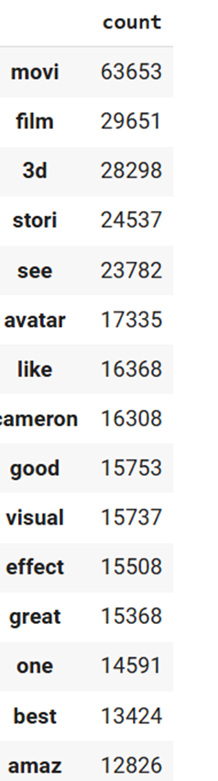 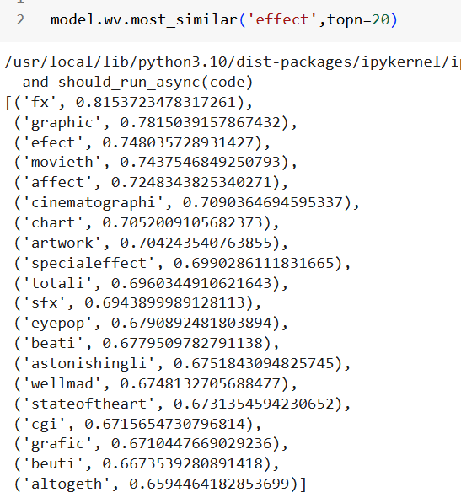

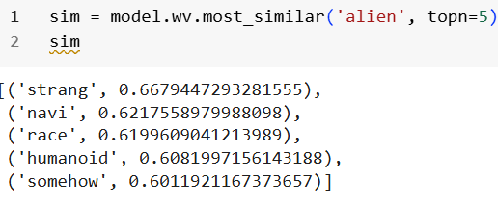 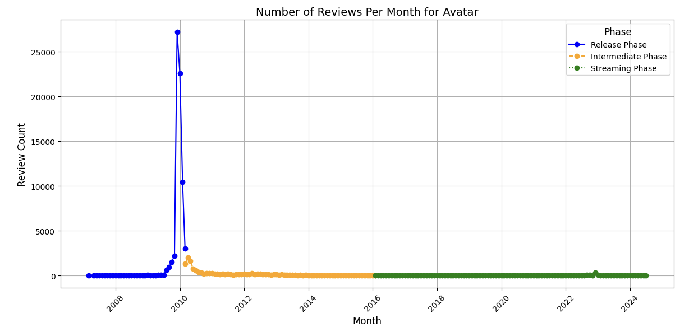

We observe the number of reviews in the release phase are the highest carrying the overall rating on the upper side. Below is the image of top words in release phase vs streaming phase.

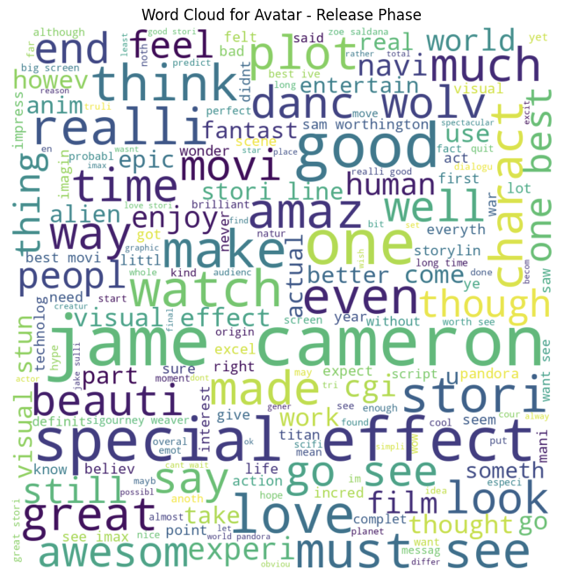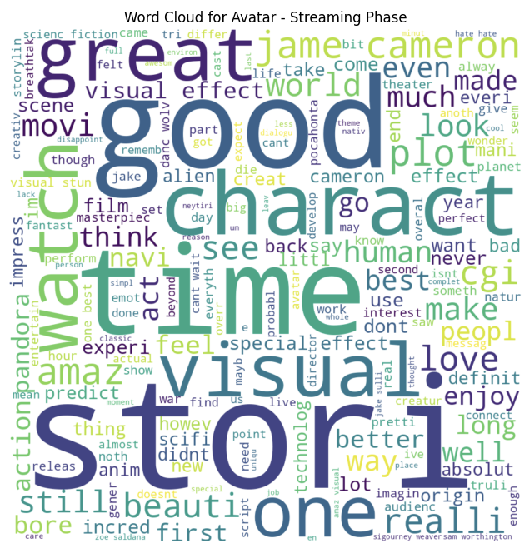

The prominent words like "special", "effect", "amaz", "beauti", and "awesom" indicate that the visual and cinematic experience of Avatar was a major draw and strength for viewers. The film seems to have captivated audiences with its immersive, groundbreaking visual effects. Words like "love", "feel", and "real" suggest the movie was able to connect with audiences on an emotional level, beyond just the technical achievements. Reviewers felt the characters, story, and themes had a genuine, impactful quality. Phrases like "3D" and "technology" imply that the expansive, imaginative scope and scale of Avatar's alien world and futuristic setting were notable highlights for viewers.

Overall, the word cloud paints a picture of Avatar as a visually stunning, emotionally compelling cinematic experience that captivated many viewers, while potentially dividing opinion on some of its deeper narrative and conceptual aspects. The sheer volume and diversity of positive descriptors point to the film's broad popular appeal.

Despite the movie being over a decade old at this point, it continues to maintain relatively high ratings, indicating that it has retained a loyal fanbase and continued viewership over time. The combination of Avatar's initial theatrical success, followed by its continued strong performance on streaming, suggests this is a film that has truly resonated with audiences in a lasting way.

##### **Home Alone:**

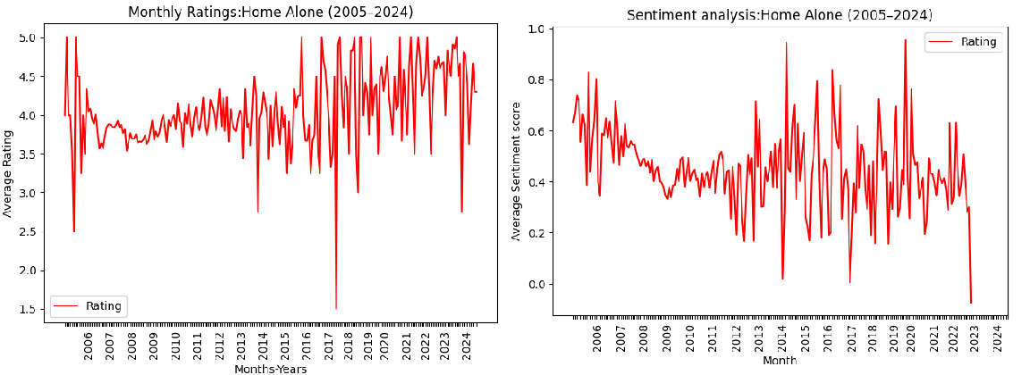

The movie seems to have gained significant popularity initially, with high ratings and positive sentiment. This is likely due to its initial release and subsequent holiday season viewings. There are noticeable spikes in both rating and sentiment around the holiday season, particularly during December. This suggests that the movie's popularity and positive reception are tied to its association with Christmas and holiday traditions. Despite the seasonal peaks, there is a general downward trend in both rating and sentiment over the long term. This could be attributed to various factors, such as changing audience preferences, the availability of newer movies, and the familiarity of the film after repeated viewings.There are periods where the sentiment score dips into negative territory. This could be due to critical reviews, controversies, or negative online discussions surrounding the movie as views on child safety and parenting became more and more rigid. Some might find the parents' negligence to be irresponsible or unrealistic.

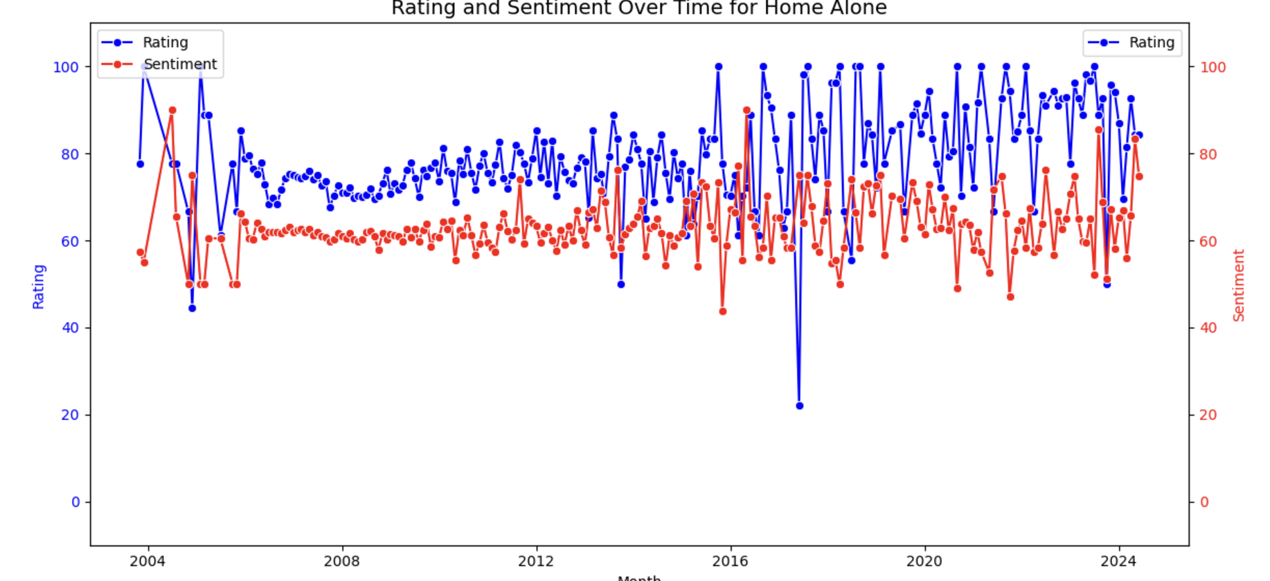

Both ratings and sentiment tend to spike around the holiday season, particularly in December. This is likely due to the film's association with Christmas and its increased viewership during this time.The graph shows that there is not a perfect correlation between ratings and sentiment as there are instances where the rating is high but the sentiment is low, and vice versa. This suggests that while viewers may enjoy the film, they may also have critical opinions or reservations about certain aspects. As viewers revisit the film over time, they may scrutinize its content more critically, particularly its violence and the portrayal of child behavior.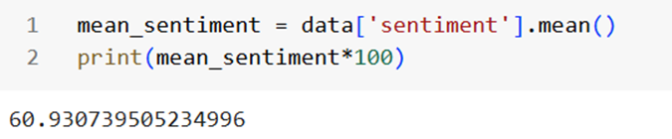

We got the average sentiment score as 60.93 which is surprising because this is a widely beloved movie and considered a classic. So we did a similar search for good and bad keywords to find although there are positive sentiments of the movie but with time and cultural shift, the audience is not able to resonate with humour or maybe don't like the way it is portrayed.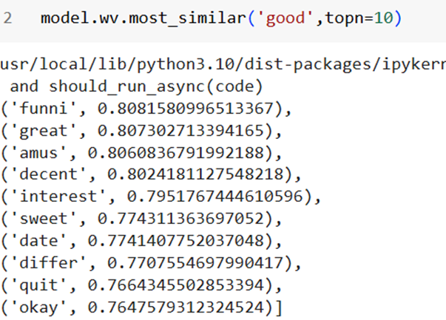 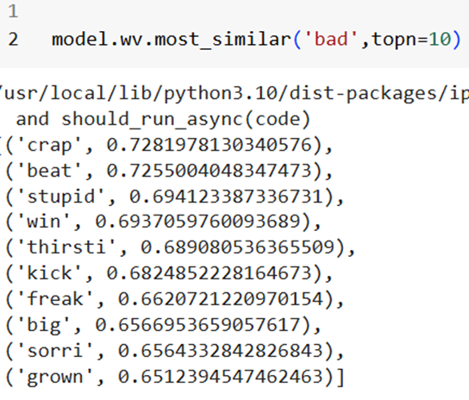

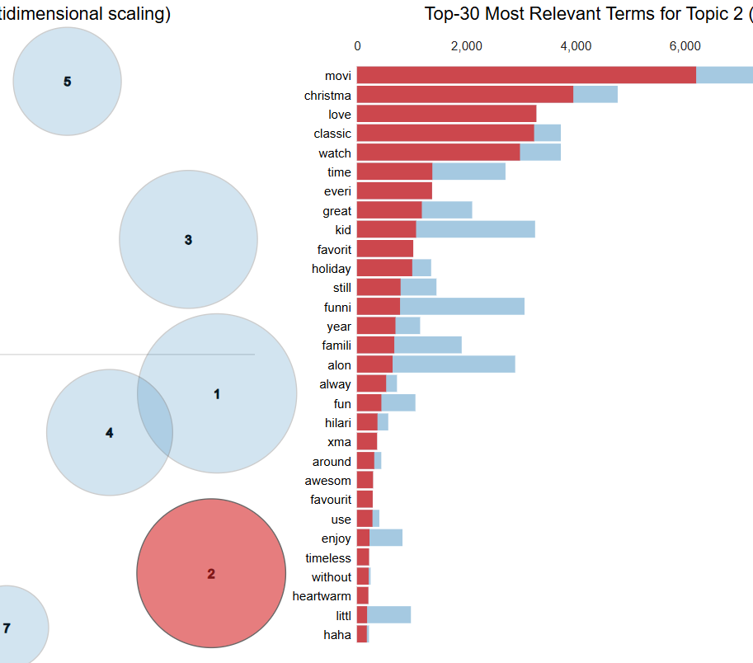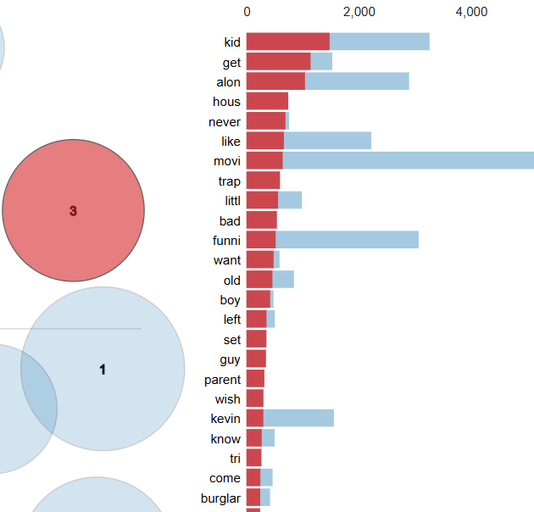

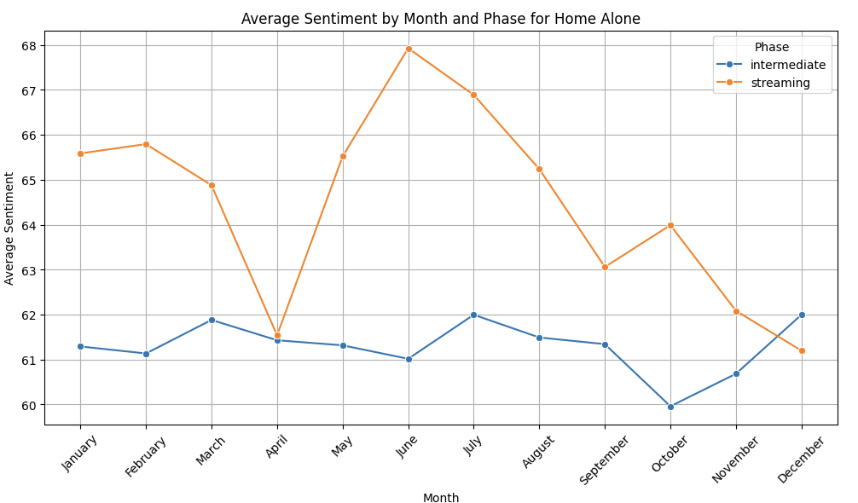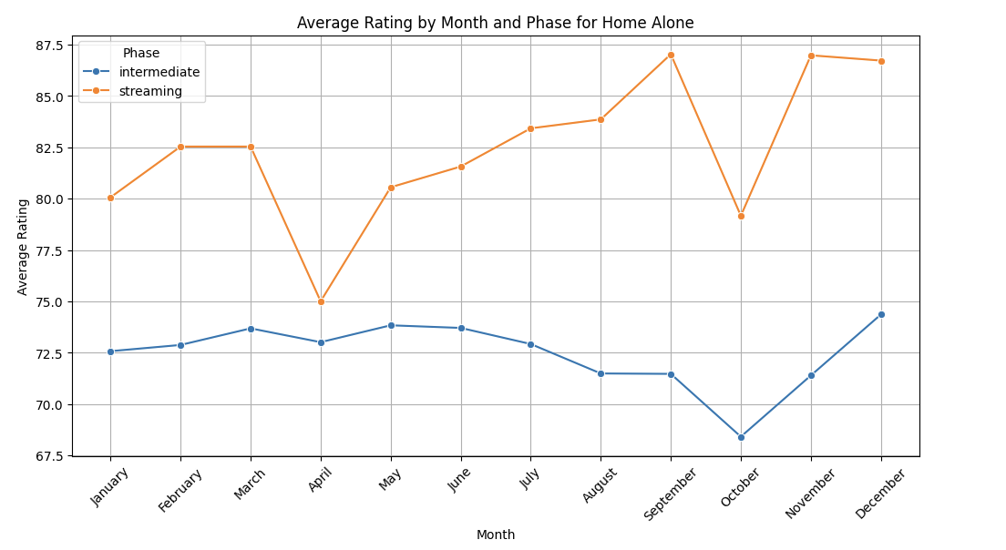

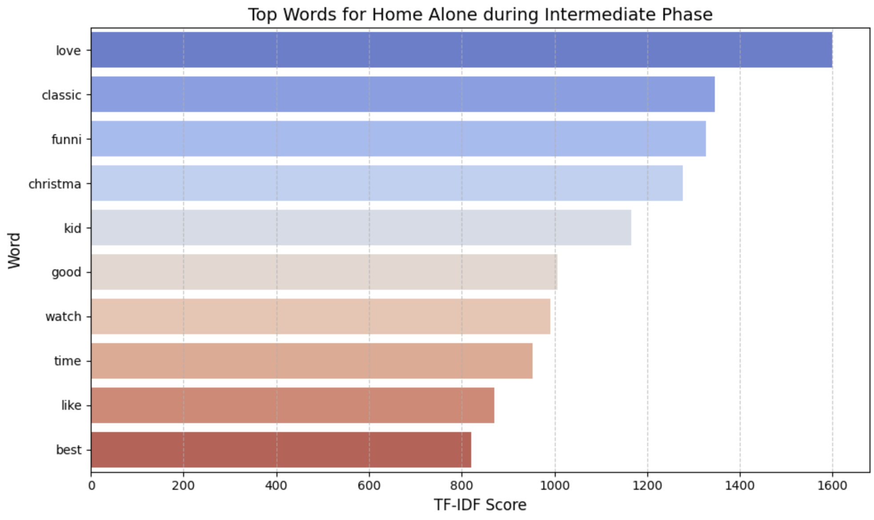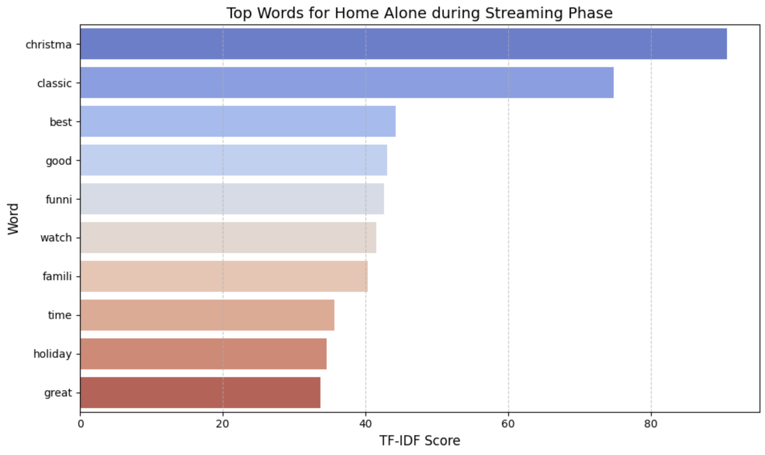

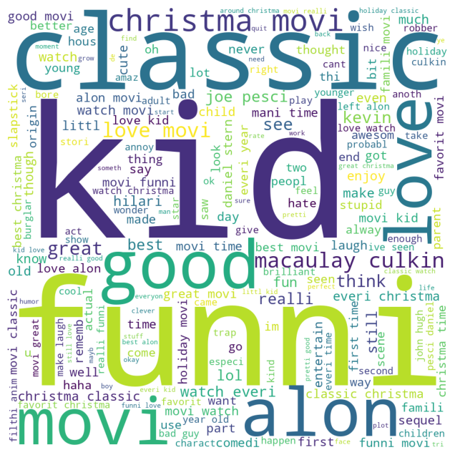

Words like "funni", "classic", "good", "love", and "kid" dominate, suggesting that the audience finds the movie humorous, nostalgic, and family-friendly. Positive adjectives like "great" and "amazing" highlight favorable sentiment. The emphasis on "Christmas" indicates the movie's association with holiday traditions.Mentions of characters like "Macaulay Culkin" and "Joe Pesci" reflect their strong connection to the movie's identity. Words like "love", "favorite", and "laugh" suggest emotional attachment and enjoyment.Phrases like "watch every Christmas" imply the movie's role as a holiday staple for many viewers. Highlighting nostalgia and humor in promotions could resonate with the target audience. Re-releasing or creating spin-offs during Christmas might amplify engagement.

Overall, Home alone appears to be a christmas light fun movie from the word cloud with generally positive tone. It is regarded as a classic holiday film that continues to entertain audiences with its humor, heartwarming moments, and Macaulay Culkin's iconic performance.

##### **The A-Team:**

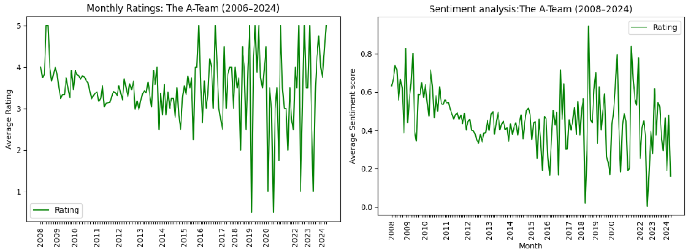

The film fell slightly short of expectations for its opening weekend as it opened behind the Karate Kid which was widely accepted. We see the sentiments for this movie show a decline throughout the first decade of the release. Ratings got better after releasing on streaming platforms and then accepted by the audience still with some fluctuations.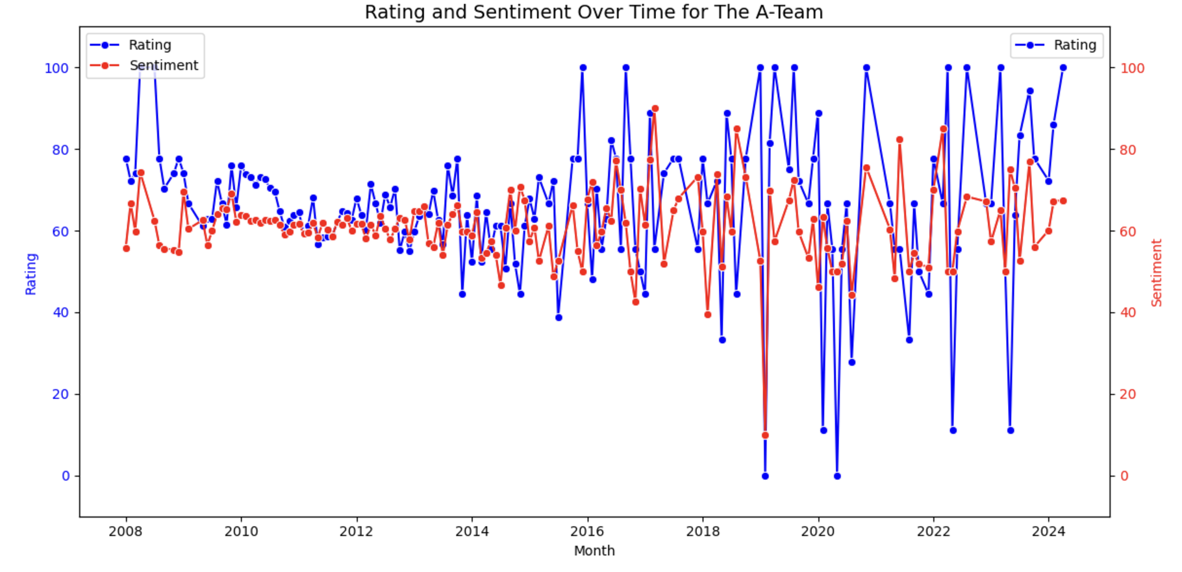

The chart clearly shows a strong overlap between the movie's ratings and sentiment scores. Periods of high ratings are closely aligned with spikes in positive sentiment, while lower ratings coincide with more negative or neutral sentiment. This suggests that audience perceptions and reviews are intrinsically linked for this film.

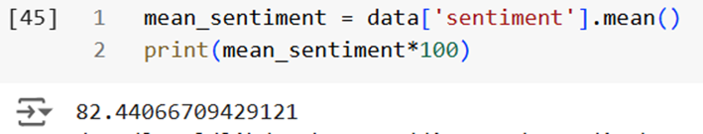

The A team got the highest sentiment score of the three movies which is curious as it was not a big hit at the time of release and gradually people started relating with it once it was available on the streaming services.

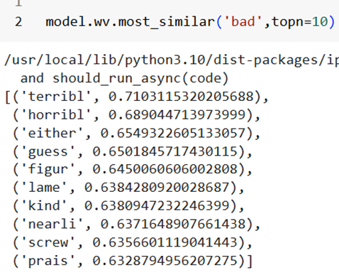 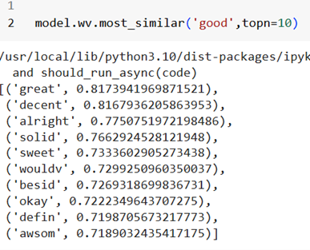

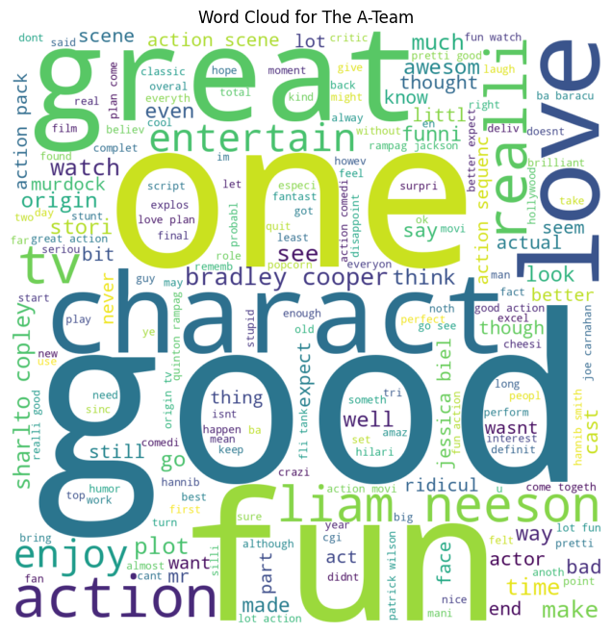 

The prominence of words like "action", "entertain", "great", "love", and "fun" suggest that the audience appreciated The A-Team for its fast-paced, thrilling action sequences and ability to provide an entertaining viewing experience. While there are some positive terms like "great" and "like" in relation to the characters, the presence of words such as "think", "better", and "didn't" implies that audience reactions to the characters and their portrayals were more mixed or divided. References to the "original" and "plan" hint that audience familiarity or expectations derived from the original A-Team TV series may have influenced their perceptions of the movie adaptation.

Overall, the word cloud paints a picture of The A-Team as an action-oriented, comedic film that provided an entertaining viewing experience for some, while failing to fully connect with or satisfy other audience members, who may have had differing opinions on the characters, quality, and fidelity to the source material.

##### **Analysis by different phases**:

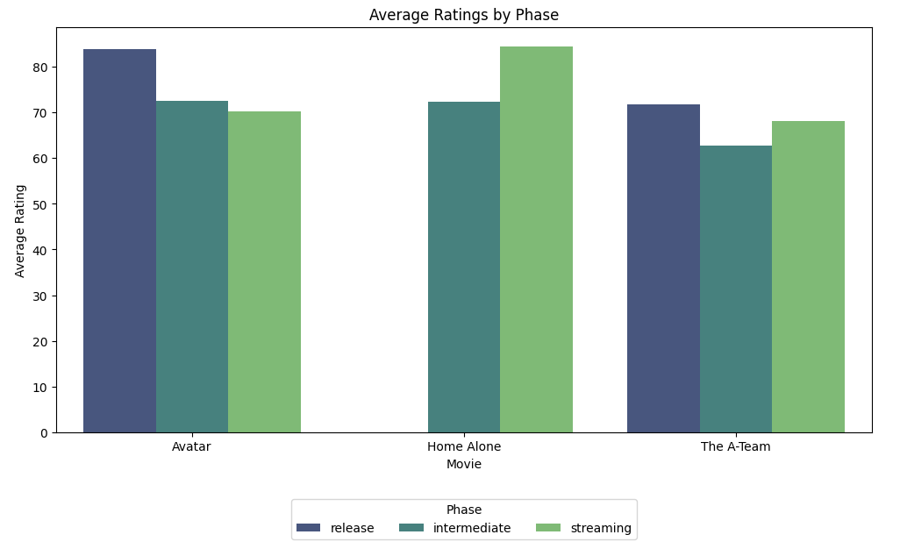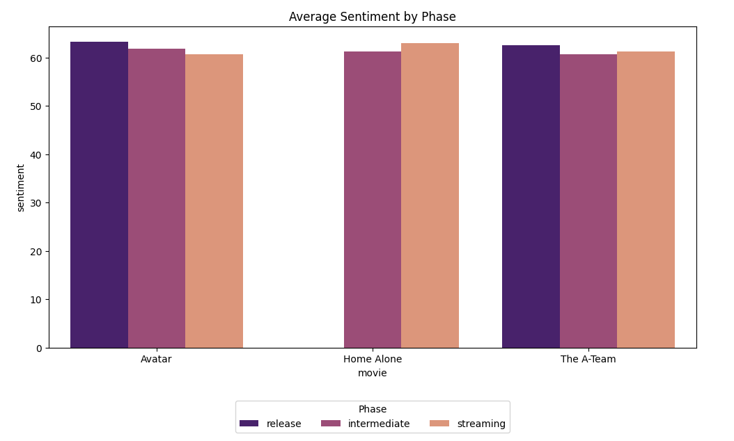

The graphs show how audience reception changes during the release, intermediate, and streaming phases for Avatar, Home Alone, and The A-Team. For Avatar, ratings are highest during the release phase, driven by excitement and its stunning visuals, but they slowly decline during intermediate and streaming phases. However, sentiment stays positive across all phases, showing its lasting appeal. The release of Avatar: The Way of Water in 2022 boosted interest in the original movie, with more people revisiting it during the streaming phase.

Home Alone has its highest ratings in the streaming phase, thanks to its strong holiday appeal as a Christmas favorite. Ratings dip slightly during the intermediate phase, but sentiment remains high, showing that audiences still feel a strong connection to the movie.

For The A-Team, ratings and sentiment are lower across all phases compared to the other movies. Ratings are highest during the release phase, but there is little improvement in the streaming phase. This suggests that The A-Team struggled to capture audience attention and has not seen much rediscovery later on.

Overall, the release phase creates the most excitement, but streaming can help sustain or renew interest, especially for movies like Home Alone. Franchise releases, like Avatar: The Way of Water, can also drive people back to older movies, keeping them relevant over time.

##### **How Release Strategies Shape Long-Term Movie Success**

The analysis of reviews for Avatar, Home Alone, and The A-Team shows clear differences in how these movies were received over time, shaped by their release strategies and audience expectations. Each film followed unique patterns in ratings and sentiment, offering insights into how viewers' perceptions changed during the release, intermediate, and streaming phases.

Avatar performed the strongest among the three, maintaining high ratings and positive sentiment throughout its lifecycle. Its theatrical release peaked with excitement due to its innovative visuals and storytelling. While sentiment dipped slightly during the streaming phase, likely because the visuals felt less impactful on smaller screens, the movie retained a loyal fanbase and continued to receive positive reviews. This shows Avatar’s timeless appeal and emotional connection with audiences, making it a standout success across all phases.

Home Alone showed a unique trend, with ratings and sentiment tied closely to the holiday season. The movie performed well during its theatrical release but saw a slight dip during the intermediate phase. However, it gained the highest ratings during the streaming phase, as viewers revisited it for its nostalgic charm and Christmas appeal. This trend highlights how a film’s association with holidays can boost its long-term popularity.

The A-Team faced more challenges. It struggled to make a strong impression during its theatrical release, overshadowed by competing films like The Karate Kid. Ratings and sentiment declined further in the intermediate phase but improved during streaming. Streaming platforms gave the film a second chance, where viewers appreciated its humor, action, and entertainment value. This shows how streaming can revive interest in films that may not have performed well initially.

In conclusion, release strategies play a major role in shaping a movie’s success. Avatar showed universal and lasting appeal, while Home Alone capitalized on its connection to Christmas traditions. The A-Team proved how streaming can give a second life to movies, even after a weak theatrical performance. This analysis emphasizes the importance of adapting to audience expectations across a movie’s lifecycle to ensure long-term success.

## **5. Conclusion and Suggestions for Data Collection**

#### **Conclusion and Takeaway**

The takeaway from this analysis is that audiences continue to review movies even after their popularity wanes. There are notable discrepancies between the author’s compiled movie data and the raw data, as well as systematic differences in how critics and audiences evaluate films. For popular movies, both critic and audience scores have the potential to predict box office revenues.

#### **Suggestions for Additional Data Collection**

A recommendation for future data collection would be to use multiple review sites, instead of one, to enhance the accuracy of the analysis and predictions regarding movies' revenue performance. Sites like Metacritic and IMDb, each with its own user base, rating scales, and sentiment analysis, could provide valuable additional insights.

To further improve this analysis, additional information, such as the audience's sentiment toward one or more actors in a movie, could be valuable in predicting the film's success. Negative press or media coverage targeting one or more actors could offer important insights into how the audience is likely to receive the movie.